**ROLE OF MAMMALIAN PARAOXONASES IN CELL PROLIFERATION AND APOPTOSIS OF TUMOR CELLS**

1. **ABSTRACT:**

Mammalian paraoxonase family comprises three highly conserved enzymes PON1, PON2, and PON3. PON1 and PON3 are present in serum lipoprotein fractions, however PON2 is an intracellular protein found in almost every tissue, particularly in the mitochondria, endoplasmic reticulum and perinuclear region. PONs are important anti-oxidative enzymes and hence detoxifying. Their roles in atherosclerosis, organophosphate degradation, diabetes, obesity and innate immunity have been established. Physiological substrate for PON2 is unknown, although it shows lactonase activity in vitro. The cytoprotective effect of PON2 through anti-apoptotic behavior is satisfactorily documented. However, the pathway by which PON2 reduces apoptosis is not clear. We have selected human hepatic carcinoma cell line (Huh7) to study the role of PON2 in cell proliferation and apoptosis. The Huh7 cells were grown with and without hydrogen peroxide (in the range of 0-50 μM) and anti-cancerous drug cis-platin (in the range of 50-100 μM) treatment. The control and treated cells were used to detect the level of PON2 expression by real time PCR. PON2 showed significantly reduced level of expression, which supports the previously reported anti-apoptotic behavior of PON2. Similarly the level PON2 also reduced when treated(in the range of 50-100µM) with drug SS209A (acetophenon compound) in Mcf-7 cell line. These studies on PON2 together with the previous reports suggest that PON2 stabilizes tumor cells, which could be a potential target for cancer treatment, however the exact mechanism is yet to be understood.

1. **KEYWORDS:**

Oxidative stress, atherosclerosis, Paraoxonases (PON), HDL, inflammation, diabetes, cancer, reactive oxygen species, organophosphates, Quorum Quenching.

1. **ABBREVIATIONS:**

ETBR- Ethidium bromide

PCR –Polymerase chain reaction

TAE –Tris –Acetate –EDTA

EDTA –Ethylenediamminetetraacetate

DNA –Deoxyribonucleic acid

RNA –Ribonucleic acid

SDS –Sodium dodecyl sulphate

MQ –Milli Q

PAGE –Polyacrylamide gel electrophoresis

PBS –Phosphate buffer saline

FBS –Fetal bovine serum

MTT- (3-(4, 5-dimethylthiazolyl-2)-2, 5-diphenyltetrazolium bromide)

DMSO- Dimethyl sulfoxide

DMNQ-2, 3-dimethoxy-1,4naptoquinon

BSA –Bovine serum albumin

DMEM –Dulbecco’s modified Eagle’s media

PSG –Penicillin Streptomycin Glutamine

PVDF –Polyvinylidine fluoride

ECL –Enhanced Chemiluminescence

APS –Ammonium per sulphate

HDL -High density lipoprotein

CHOP- C/EBP homologous protein

LDL –Low density lipoprotein

AHL –Acyl homoserine lactones

ROS –Reactive oxygen species

PON –Paraoxonases

cDNA –Complementary DNA

1. **INTRODUCTION:-**

During normal metabolic process, highly reactive compounds called free radicals are generated in the body and these molecules are inherently unstable as they possess lone pair of electrons and hence become highly reactive compound (ROS)(Krishnamurthy and Wadhwani, 2012). They react with cellular molecules such as proteins, lipids and carbohydrates, and denature them. As a result of this oxidative stress, vital cellular structures and functions were lost and ultimately resulting in various pathological conditions like cancer, diabetes, Alzheimer’s disease, strokes, heart attacks and atherosclerosis. As we already know that oxidative stress arises due to the imbalance in the production of reactive oxygen species (ROS). ROS also able to trigger numerous transcription factor and cause the changes in normal gene function and play major role the development of tumorigenesis, angiogenesis and neoplastic growth. Implication of these oxidative stress i.e., diseases draw critical attention on to the study of enzymes that govern the anti-oxidative role. One of such family of enzyme PARAOXONASES is gaining immense focus as antioxidant. These enzymes are capable of stabilizing, or deactivating free radicals before they attack cellular components. Antioxidant enzymes are, therefore, absolutely critical for maintaining optimal cellular and systemic health and well-being.

These enzymes also hydrolyses wide range of substrate such as organophosphate compound, insecticides ,nerve agent and many more which are yet to be discovered. Further, it has been already reported that these enzymes are associated with various disease.(Eren et al., 2012), however their route of action still unknown, so identifying their physiological role which could prevent from inflammatory disease, lead to the creation of novel therapy that might help in the treatment of various oxidative inflammatory diseases.

The paraoxonase (PON) gene family comprises three highly conserved enzymes PON1, PON2, and PON3, located on chromosomes 7 in human, (6 in mouse). PON1 and PON3 are found in liver and associated with high density lipoprotein (HDL), these enzymes PON1 & PON3 are very much similar in function, however PON2 is an intracellular protein found in almost every tissue , particularly in the mitochondria, endoplasmic reticulum and peri-nuclear region of so many vital organ(Levy et al., 2007) such as liver, lung, heart, placenta, testis, stomach, spleen, pancreas, small intestine, skeletal muscle, artery wall cell and macrophages(Ng et al., 2001).

1. **HUMAN PARAOXONASE-1**

In 1940 PON1 was the first discovered by Mazur and they reported their enzymatic activity found in mammalian tissue which was capable of hydrolysing wide range of substrate such as organophosphate pesticides (OP), lactones, neurotoxicants (serin and soman) and aromatic esters.(Ponce-Ruiz et al., 2015) PON1 is a glycoprotein of 354 amino acids and approximate molecular mass of 43 KDa, is a calcium dependent esterase that synthesized in liver and secreted into the plasma where it associated with high density lipoproteins, and play important role in inhibiting the oxidation of low-density lipoproteins (LDLs) and preventing the development of atherosclerosis(Aviram et al., 1998).

1. **HUMAN PARAOXONASE-2**

The human enzyme paraoxonase-2 (PON2) has two functions, first the reduction of intracellular oxidative stress and an enzymatic lactonase activity(Altenhöfer et al., 2010). By its anti-oxidative effect, PON2 reduces cellular oxidative damage and influences redox signalling, which promotes cell survival. This may be appreciated but also deleterious that high PON2 levels reduce atherosclerosis but may stabilize tumor cells as well. PON2 indirectly but specifically reduced superoxide release from the inner mitochondrial membrane, wherein it functions as an anti-oxidative protein by reducing intracellular and local oxidative stress. Secondly as a lactonase, it dominantly hydrolyses bacterial signalling molecule 3OC12 and may contribute to the defence against pathogenic Pseudomonas aeruginosa.(Chen et al., 2013; Teiber et al., 2008)

Although PON2 has a similar structure to that of PON1 based on high amino acid sequence homology, PON2 possesses biological functions that are distinct from PON1. PON2 cannot hydrolyse organophosphates, such as paraoxon, but possesses hydrolase and lactonase activity.

1. **LITERATURE REVIEWS:-**
2. **STRUCTURAL ANALYSIS:-**

Structure analysis of PONs has been observed that these enzymes have problem in folding and

are unstable and tend to aggregate forming inclusion body in the absence of detergent. These factor illuminated the need to identify PON variant, which should be easily soluble in bacterial system(Aharoni et al., 2004). Due to such led the formulation of PON1 variant, which was articulated through genetic shuffling of various PON1 member from different mammalian species hence the recombinant PON1 was soluble in E.coli.(Aharoni et al., 2004)

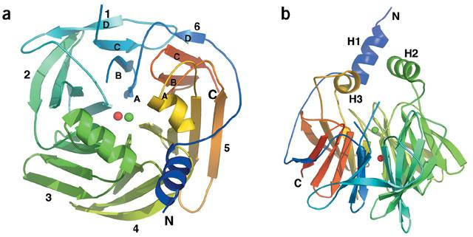**Figure: 1**

**(a)**Ribbon structure of PON1 displaying six-bladed beta propeller fold with N and C termini, and the 2 calcium atom in the central tunnel of the propeller. Ca1 green and Ca2 in red **(b)** A side view of the propeller, including the three helices at the top of the propeller (H1 and H3) that are involved in HDL association.(Harel et al., 2004)

The recombinant PON1 structure contain 6 bladed beta propeller structure and each blade contain 4 strands. The mature protein retains its hydrophobic leader sequence (except the N-terminal methionine) allowing its association with HDL(Harel et al., 2004). The structure also has a unique active site lid which may modulate the association with HDL. The PON1 structure contains 2 Calcium, one at the base of the active site (adjacent to a phosphate ion) which was involved in the catalytic mechanism, and other Calcium was found that involved in enzyme stability. These calcium ions 7.4 Å apart, are seen in the central tunnel of the propeller, one at the top (Ca1) and other in the central section (Ca2). Ca2 is most probably a ‘structural calcium ‘whose dissociation leads to irreversible denaturation, however Ca1 is assigned as the ‘catalytic calcium’ which interact with five protein residues (the side chain oxygen of Asn224, Asn270, Asn168, Asp269 and Glu53), 2.2–2.5 Å away.(Kuo and La Du, 1998) and also two other potential ligands of water molecule and one of the oxygen of a phosphate ion. The two calcium ions exhibit markedly different affinities. Ca1 ligation is more extensive than Ca2. However, two of Ca1’s ligating residues (Asn224 and Asp269) exhibit distorted dihedral angles. This indicate that Ca2 is the higher-affinity than Ca1(Yeung et al., 2004). PON1 contain three helices H1, H2 and H3 connected by loops to the beta propeller scaffolds and the helices observed to cover the active site of the protein which might pose a significant role in PON1 function. (Harel et al., 2004)

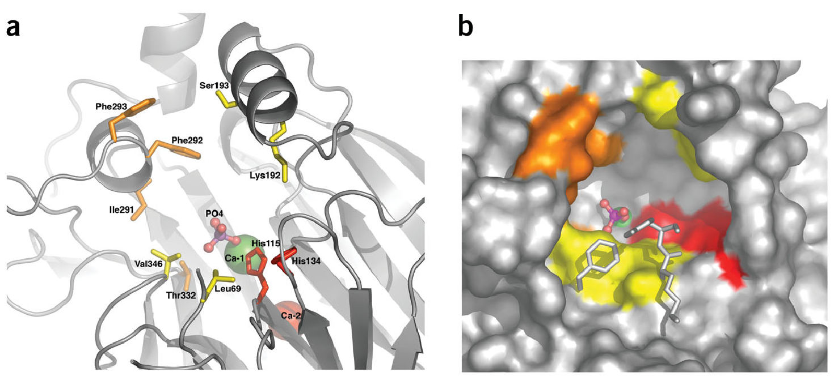

**Figure 2(a)** Central tunnel of the propeller with the two calcium atoms, and the side chains of the residues found to be mutated in the newly evolved PON1 variants for esterase and lactonase (orange) or for phosphotriesterase activity (yellow). The putative catalytic His-His dyad was shown in red.

**(b)**A surface view of the active site consisting of Lys70, Tyr71, and Phe347.

**b) FUNCTIONAL ANALYSIS:-**

1. **Role of PONs against Cis-platin induced apoptosis:-** To study the role of PON2 in cell proliferation and apoptosis, cells are treated with one of most potent anti tumor drug cis-platin and their cytotoxic mode of action is mediated by its interaction with DNA to form DNA adducts, The cisplatin is mainly interact with nucleophilic N7-sites of purine bases in DNA to form DNA–protein and DNA–DNA interstrand and intrastrand crosslinks, i.e., intrastrand adducts which is responsible to activate several signal transduction pathways, including p53 mediated apoptosis. This form of cell death is a complex, process that begins with the translocation of the cisplatin-induced Bax from the cytosol to the mitochondria, where a cascade of events, involving the release

of apoptogenic factors (such as cytochrome- c) activates the caspase 9–caspase 3 pathway, and results in apoptosis.(Siddik, 2003)

CIS-PLATIN

DNA ADDUCTS

DNA RECOGNITION PROTEIN

P53

Bax

Casp-9

Cyt c

Casp-3

Apoptosis

Oncogene (2003) 22, 7265–7279

**Figure-3** Showing an overview of pathways

Involved in mediating cisplatin-induced Cellular apoptosis

1. **PONs provides apoptosis resistance and stabilizes tumor cell: -** Oxidative damage and ER stress-induced apoptosis both are diminished by PON2.(Witte et al., 2011) ER stress has very much relevant to cancer because it produces ROS and which accumulate the unfolded proteins in the endoplasmic reticulum, and these increase accumulation of unfold protein response(UPR) leads dissociation of Bip(Binding immunoglobulin Protein) from lumen and activate three receptors IRE1, PERK and ATF6(Nishitoh, 2012) which induce the signal transduction pathway.

Bip

Unfolded

protein

PERK

eiF2α

ATF4

p

CHOP

PON2

Endoplasmic

Reticulum

p

p

XBP-1

p

p

Apoptosis

Survival

ATF6

IRE1

Cell Death and Disease (2011) 2,

e112; doi:10.1038/cddis.2010.91

J. Biochem. 2012; 151(3):217–219 doi:10.1093/jb/mvr143

ER/Oxidative stress

**Figure -4** Pathway shows PON2 prevent cell apoptosis

In the early stage IRE1(inositol requiring kinase) dimerise and transphosphorylate and activate the XBP1(X-bow binding protein) which regulate the transcription and degrade the unfolded protein.(Liu et al., 2015), hence it promote the cell survival. But later stage prolonged accumulation of ROS lead the continuous accumulation of UPR(unfolded protein response) dissociate the BIP and trigger the phosphorylation of PERK dimeri se and phosphorylates the eiF2α which inhibit the translation and activate ATF4 (Nishitoh, 2012)which finally induce the CHOP inside the nucleus when bind with GADD34(growth arrest DNA damage 34) and finally leads apoptosis(Liu et al., 2015). But in ER stress condition increased PON2 level decreased the production of ROS as well as decrease the induction of pro-apoptotic CHOP provide apoptosis resistance and stabilize the tumor cell.(Witte et al., 2011)

1. **Role of PONs in atherosclerosis:-**

Atherosclerosis is occur due to hardening and narrowing of the [arteries](http://www.webmd.com/heart/picture-of-the-arteries) and cause of [heart attacks](http://www.webmd.com/heart-disease/guide/heart-disease-heart-attacks), strokes, and peripheral vascular disease which together are called "[cardiovascular disease](http://www.webmd.com/heart-disease/default.htm)." These constitute the major mortality rate in worldwide(Eren et al., 2012). Arteries are the blood vessels carrying blood from heart to other parts of the body. These vessels are lined by endothelium cells that maintain the integrity of these vessels. Today’s passive lifestyle is one of the main contributors towards the disruption of these endothelium cells. Now, when low density lipoproteins encounter such cells they penetrate the arterial wall owing to which white blood cells attack these cholesterol moieties such a phenomenon progressing over a large period of time results in the formation of plaques which constitute cells, cholesterol and debris. These plaques finally result into the cardiac malfunctions that we encounter today. (Besler et al., 2012)

1. **Role of PONs** **and quorum quenching:-**

Quorum sensing (QS) is a bacterial cell to cell signalling system which controls the production of virulence factors in many pathological bacteria. QS is mediated by the production of autoinducers, small signal molecules which activate or repress gene expression when a minimal threshold concentration is reached.(Chen et al., 2013) N-acyl homoserine lactones (AHLs) are used as autoinducers by many gram-negative pathogens such as Pseudomonas aeruginosa to control the expression of virulence factors. AHLs are degraded by lactonases which is termed quorum quenching and the production of these enzymes is an effective way to interfere with QS and prevent bacterial virulence (Chen et al., 2013; Mackness and Mackness, 2015; Teiber et al., 2008).

Further studies indicated that PON1 expression decreased superoxide anion levels and altered the expression of multiple genes related to oxidative stress. These indicate that PON1 poses the attractive target in infection and quorum sensing.

1. **Role of PON2 in brain as neuroprotection:-**

PON2 is unique among the three PONs, as it is expressed in brain tissue. It has been found that high level of PON2 found in dopaminergic region of brain (substantia nigra, striatum, and the nucleus accumbens), where dopamine metabolism cause the formation of oxidative stress in these region.(Giordano et al., 2011) However, it has been also estimated that high level of PON2 in astrocyte than neuronal cell. They take astrocyte from mice PON2+/+ and PON2-/- ,checked the oxidant-induced toxicity by exposure H2O2 for 60 min (for ROS measurements) or 24 h (for cytotoxicity) with 10 μM H2O2 or 5 concentrations of H2O2, respectively. ROS levels were measured by the dichlorofluorescein method, while cytotoxicity was assessed by the MTT assay and conclude that cells from mice lacking PON2 were more susceptible to the toxicity of both by a factor of 5 to 11-fold. They also treated with DMNQ (2,3-dimethoxy-1,4naptoquinon) (10 μM) and showed increased ROS to ~400% from PON2−/− mice, and only 170% in the same cells from PON2+/+ mice, suggesting that the differential susceptibility to oxidant was primarily due to the presence or absence of PON2.(Costa et al., 2014; Giordano et al., 2011)

1. **Modulation of PON2:-**

Most studies concerning the induction of PON2 expression by various stimuli have focused on oxidative stress because PON2 plays a role as an intracellular antioxidant. Both in vitro and in vivo studies have demonstrated that PON2 expression and enzymatic activity increase during oxidative stress. PON2 is up-regulated in response to oxidative stress in different cell types (HepG2 cells and macrophages),animal models(mice fed high fat diets and apoE knockout mice), and in hypercholesterolemic patients (Forte et al., 2002; Shih et al., 1996). Mouse peritoneal macrophages (MPMs) that were treated with various agents that induce oxidative stress have demonstrated increased PON2 expression and lactonase activity(Rosenblat et al., 2003). Shiner et al. have observed an approximate seven-fold increase in PON2 expression during monocyte/macrophage differentiation that was dependent on the presence of nicotinamide adenine dinucleotide phosphate (NADPH), and this phenomenon was observed to correlate with an increase in cellular oxidative stress(Shiner et al., 2004). In addition, PON2 has been found to be inactivated during low levels of oxidative stress. Therefore, high levels of oxidative stress may induce a cellular compensatory mechanism that up-regulates PON2 expression in macrophages (Shiner et al., 2007)

**6) MATERIALS AND METHODS**:-

**REAGENTS**

* 10X PBS (Gibco): 10.59 mM KH2PO4, 1551.72 mM NaCl, 29.66 mM, Na2HPO47H2O
* DMEM,RPMI media,( Freezing medium 90% FBS and 10% DMSO**)**
* Cis-platin:0.015 gm in 1ml DMSO
* MTT solution : 5mg/ml MTT in PBS
* Drug (SS209A) (Mol. Formula- C21H16N202S):- 0.36mg in 1ml DMEM
* H2O2: 30%w/v (mol.wt- 34) 1µl 8.823M in 1ml DMEM.
* Lipofectamine 2000 (Invitrogen)
* PON3 insert concentration:-612.2ng/µl (6.5µl insert req.for 4µg)
* Vector concentration : 762.2 ng/µl (5.2µl req.for 4µg)
* Opti-MEM media
* Ripa buffer and protease inhibitor cocktail(50:1) both from (Thermo scientific)
* 10X TBS (Himedia):150 mM NaCl, 2 mM KCl, 25 mM Tris, pH 7.4
* 1X TBS-T 0.1% V/V Tween 20, 1X TBS
* Tris Base (pH 6.8), 1M:12.12 gm Tris base dissolved in 1 litre MQ water
* Tris Base (pH 8.8), 1.5 M:18.18 Tris base dissolved in 1 litre MQ water
* 10% SDS: 5 gm SDS was dissolved in 50 ml dH2O.
* 10% APS (Ammonium persulphate) 0.1gm APS was dissolved in 1 ml dH2O. Fresh APS was prepared for electrophoresis.
* 10X Running buffer (Himedia):25mM Tris, 191mM glycine, 0.1% SDS, pH-8.3
* Primary antibody PON1-3 (H-300) rabbit polyclonal antibody.
* Secondary antibody goat anti-rabbit IgG-HRP (from santa cruz biotechnology)

**i. Cell culture and treatment**:- Human mammalian cancerous cells (HUH-7,MCF-7 & HEK293) were maintained in Dulbecco’s Modified Eagle’s Medium (PC-3 in RPMI)supplemented with 10% fetal bovine serum and 1% PSG (Penicillin, Streptomycin, Glutamine). The cell culture maintained in 25mm flasks in an incubator at 5% CO2 and 37ºC atmospheric temperature. The cells were grown up to 80%-90% confluency in a T25 flask and then, were either used for performing an experiment or sub-culturing. The cells were plated at density of (1.5-2) × 10^5 cells/ml and and allow to attach for 24-48hr before the treatments. Treatment were performed in 6 well plates containing 2 × 10^5 cells per well, treated with (**a)** 50µM cis-platin after reaching (60-70%) confluency and , 2µl DMSO as with control was used ).(**b**) H2O2 treatment with 20µM and 40µM .Cell number and morphology was affected by treatment or time when compared with control.

**ii. Passaging the cells**- Utilized media was removed following which the cells were rinsed with 2 ml(for T25 flask) and 4 ml (for T75 flask) PBS (Ca and Mg free) to remove the serum proteins, which may inhibit the activity of trypsin. PBS washing was given for about 1minute.Now this PBS was removed and cells were trypsinzed with 0.005% trypsin-EDTA (Invitrogen) for 5 minutes at 37ºC. Following this the media was added to inhibit the trypsin and spread with help of a pipette to detach the cells from the flask. The media containing cells was transferred to a 15ml falcon tube and centrifuged at 1000 rpm for 5 minutes at 4ºC. The supernatant was discarded and the pellet was re-suspended in fresh media by pipetting several times to break the clumps. Now the cells were transferred to a fresh T25 or T75 flask for sub-culturing or were counted using a haemocytometer under the influence of a light microscope (Nikon) for experimental purpose.

**iii. Freezing the cells** - Cells were harvested at 1000rpm following trypsinization and the cell pellet was re-suspended in freezing media (90% fetal bovine serum and 10%DMSO). 1 ml of cell suspension was transferred to the cryovials labelled with date of freeze down, cell line and other details. From each T25 and T75 flask 2 and 3 freeze down were made respectively. Vials were transferred to cryobox filled with isopropanol. The cryobox was stored in -80 degree Celsius for 24 hours so that the vials can be frozen at 1 ͦ C/minute for 24 hours before transferring to liquid nitrogen tank (-196 ͦ C) for log time storage. To revive the cells, the vials of desired cell line were taken out of liquid nitrogen tank. The vial was thawed and the cells were transferred immediately to flask containing media and then incubated at 37 ͦ C under 5% CO2.

**iv. Isolation of total mRNA: -** Total RNA was prepared from cultured (MCF-7, HUH-7 & PC-3) cells using the TRIZOL reagent according to manufacturer’s instructions (aMRESCO biotechnology). Cells are washed twice with PBS (1ml). 1ml trizol was added to the cells and shake properly for 2-4 minute till the cell detached, after than collect in fresh eppendorf tube and homogenised for 5 min at room temp. 200ul of chloroform was added and vortex for 15 second. Tube was leave for 2-3min at RT and centrifuged at 12000 rpm for 15min at 4ºC. The aqueous layer was transferred in fresh 2ml eppendorf tube and added 500µl isopropanol, vortex for 15 second and centrifuged for 10min at 12000rpm .Supernatant was discarded and added 1ml of 70% ethanol, mixed and again centrifuged at 7500rpm for 5min at 4ºC. Again supernatant was discarded and dried for 20min at RT. After transparency the pallet was dissolve in 100µl DEPC water, and stored in -80ºC. RNA was quantified at 60nm and the purity was assessed by measuring the O.D.260/O.D.280 ratio using nano drop. RNA integrity was evaluated by electrophoresis of RNA sample on 1% agarose gels (5µl RNA sample with 1µl 6X loading dye)

**v. cDNA synthesis: -** cDNA synthesis was done using cDNA synthesis kit from Thermo scientific. 2µl of RNA sample was used as template, 1µl Oligo dt primer and 9µl of nuclease free water was added. Now the total volume was 12µl. It was mixed and incubate for 5 min at 65ºC. After 5 min of incubation, 4µl of 5X reaction buffer, 1µl of Ribolock RNase inhibitor, 2µl of 10mm dNTP mix and 1µl of Revert Aid H minus M Mul V Reverse transcriptase were added to make volume up to 20µl. This was mix gently and kept in PCR machine for 60min at 42ºC. After than it was stored at -20ºC.

**vi. Amplification of cDNA by gene specific primer PON1, 2 and 3:-**

* **Primer utilized for PON 1, 2, 3 and β-actin.**

|  |  |  |  |
| --- | --- | --- | --- |
| **Primer** | **Sequence** | **Length** | **Melting temperature** |
| 1. **PON1** |  |  |  |
| Forward primer | 5’CTGTGGGACCTGAGCACTTTT-3’ | 21 | 57.5ºC |
| Reverse primer | 5’TGCCATCGGGTGAAATGTTG-3’ | 20 | 56.1ºC |
| 1. **PON2** |  |  |  |
| Forward primer | 5’ACTTGAACTTACACTGGGCAAA-3’ | 22 | 54.8 ºC |
| Reverse primer | 5’CATGAGCCAATATGTCAGCAACA-3’ | 23 | 55.7 ºC |
| 1. **PON3** |  |  |  |
| Forward primer | 5’CAGTTGGGCACCTTAGTGGA-3’ | 20 | 57.1 ºC |
| Reverse primer | 5’ATTGTTGGCATACACGGTGC-3’ | 20 | 56.3 ºC |
| 1. **β-actin** |  |  |  |
| Forward primer | 5**’-**CTGGCACCCAGCACAATGAAG-3’ | 21 | 59.0ºC |
| Reverse primer | 5’GTCATAGTCCGCCTAGAAGCAT-3’ | 22 | 56.3 ºC |

* **PCR protocol :-**

|  |  |  |
| --- | --- | --- |
| COMPONENT | QUANTITY (µL) | WORKING CONC. |
| Nuclease free water | 37 |  |
| Forward primer | 2.5 | 10mM |
| Reverse primer | 2.5 | 10mM |
| Reaction buffer | 5 | 1x |
| Template (cDNA) | 1 |  |
| dNTP | 1 |  |
| Taq polymerase | 1 |  |
| **Total** | **50µl** |  |

* **PCR cycle**

95ºC for 2minute

1st step denaturation

95ºC for 10 second

58ºC for 30 second

72ºC for 1 minute

2nd step annealing

72ºC for 10 minute

4ºC for ∞

3rd step elongation

**vii. Transfection of PON3 (cloned in pcDNA) form mouse in HEK-293 cell:-**

Transfection of the plasmid was performed with the help of lipofectamine 2000 reagent (Invitrogen). HEK-293 cells culturing in two T25 flask having confluency of 70%-80% were trypsinized using the above described protocol. Following which trypsin was inactivated by adding fresh media containing 10% FBS and was centrifuged at 1000 rpm for 5 minutes. Then, the supernatant was discarded and cell pellets were resuspended into 1 ml complete DMEM media. Cells were counted using haemocytometer and 1.5 × 10cells were plated into one 6-well plates and marked as a control (cell and media), vector (cell, media and vector), insert (cell, media and plasmid), and control for DMEM and opti-MEM. Then preparation of transfection reagents were carried out. Lipofectamine (12µl) was added with 300µl of opti-MEM, mixed properly and incubate for 5min for RT. Three eppendorf tube was taken and 100µl of opti-mem was added in each tube. In 1st and 2nd tube 4 µg/ µl insert and vector was added respectively (conc.of plasmid 612.2ng/µl, vector 762.2ng/µl). From the previously made lipo/mem complex 104µl was added in all three tubes. Incubate for 20 min at RT. From the 6 well plate media was removed and added 800 µl of opti-MEM, incubate for 1 hour to maintain the suitable environment before transfection. After than 200µl of insert, vector and lipo/mem complex was added in their respective well and incubate for 4 hour at 37ºC. Than 1ml of DMEM was added in all well to reach final volume 2ml. Incubate in 5%CO2 incubator for 48hour at 37ºC. (**a)** RNA was isolated by trizol method, cDNA was synthesized and amplified with gene specific primer and expression level was checked as previous mentioned protocol. (**b)** Cells are lysed with lysis buffer(RIPA) and sonication was done and after centrifugation, the supernatant was collected and protein quantification was done by BCA method and further western blot to check the specific protein.

**viii. Cell lysis**: - Plates were taken out from the incubator and placed on ice. Media was removed from the plates and the cells were washed with PBS (1 mL/ well). Ripa buffer and protease inhibitor cocktail both from (Thermo scientific) were mixed in a ratio of 50:1 and were added to the wells (180μl/ well) after the complete removal of PBS. The plates were kept on ice for 10 minutes, following which the cells were scraped using a cell scraper and collected in a fresh 1.5 mL micro-centrifuge tube. These tubes were kept in ice and taken for sonication Cells were lysed by sonicating at 15% amplitude for 10 seconds for 1 cycle. Cells were centrifuged at 10000 rpm, 4ºC for 10 minutes. Supernatant was transferred in a fresh micro-centrifuge tube and the pelleted cell debris was discarded. The supernatant collected was immediately used for further experiments and protein estimation after which were stored at -20ºC.

**ix. Protein assay by Bicinchoninic acid (BCA):-**

|  |  |  |  |
| --- | --- | --- | --- |
| Conc.of BSA mg/ml | BSA (µl) | PBS (µl) | TOTAL (µl) |
| 0 | 0 | 25 | 25 |
| 0.1 | 2.5 | 22.5 | 25 |
| 0.2 | 5 | 20 | 25 |
| 0.4 | 10 | 15 | 25 |
| 0.6 | 15 | 10 | 25 |
| 0.8 | 20 | 5 | 25 |
| 1.0 | 25 | 0 | 25 |
| Sample(µl) | PBS(µl) | TOTAL(µl) |
| 2.5 | 22.5 | 25 |
| 2.5 | 22.5 | 25 |
| 2.5 | 22.5 | 25 |
| 2.5 | 22.5 | 25 |
| 2.5 | 22.5 | 25 |

Protein standard ranging from 0.1 to 1mg/ml in Phosphate Buffer Saline were prepared using Bovine Serum Albumin as the standard. Standard BSA was measured as fallow:-

200µl of working reagent are added in each well. (Working reagent –A and B in 50:1ratio) and the plate was covered with foil and incubated at 37ºC for 30 minutes. After the incubation reading was taken at 590nm using multimode reader. Then a standard graph was plotted using Microsoft excel and the concentration of the purified protein was measured.

**x. Western blotting:-**

* **SDS-PAGE:** After protein estimation all samples were loaded on a 12% SDS gel in equal concentrations. Component of 12% SDS gel as fallows-

Separating gel stacking gel

|  |  |
| --- | --- |
| MQ water | 2.1 ml |
| 30% acrylamide | 0.5 ml |
| Tris(1.0M, PH-6.8) | 0.38 ml |
| SDS (10%) | 30µl |
| APS (10%) | 30µl |
| TEMED | 3µl |
| MQ water | 1.6 ml |
| 30% acrylamide | 2.0 ml |
| Tris(1.5M, PH-8.8) | 1.3 ml |
| SDS (10%) | 50µl |
| APS (10%) | 50µl |
| TEMED | 5µl |

* **Sample preparation for SDS-PAGE**

Protein samples were loaded 4ug/well and 4X protein loading dye was mixed in a ratio of 3:1. This was then boiled at 95ºC for 10 minutes in order to denature proteins. Samples were loaded on the gel along with a protein marker. The gel was initially run at 80V, which was increased to 120V when the samples reached resolving gel. The run was stopped when the dye reached the bottom of the gel.

* **Electro-transfer to PVDF Membranes**

PVDF membrane was cut to the size of gel and was dipped in methanol, following which it was dipped in 1X transfer buffer. The components of the transfer assembly (sponge, absorption papers) were all soaked in 1X transfer buffer. To start assembling the transfer cassette, a sponge was placed towards the black side of the cassette followed by blotting paper, gel and PVDF membrane. The air-bubbles were removed by rolling a pipette over the membrane. Another blotting paper and sponge were placed on the membrane. The cassette was closed and was placed in the transfer apparatus filled with 1X transfer buffer. The gel was transferred at 60V for 1.5hours with the transfer tank placed on ice.

* **Blocking and Antibody Incubation:-**

The PVDF membrane was blocked using 5% skimmed milk in 1x TBS-T for an hour. Primary antibody (1:1000) was added after removing blocking solution and was incubated overnight at 4ºC with shaking. The membranes were washed 5 times with 1X TBS-T (5 minutes each wash). Following which secondary antibody (1:5000) was added and incubated for 1 hour at room temperature with shaking. The membranes were washed 5 times (5minutes per wash) with 1X TBS-T.

* **Detection of proteins with ECL:-**

ECL mix was prepared by mixing Reagent A (Luminol) and Reagent B (Peroxidase) in the ratio of 1:1. This was then spread over the entire membrane, drop-by-drop, after which the membrane was transferred to an X-ray hyperactive cassette. An X-Ray film was kept over the membrane and was incubated for a 1 minutes in dark. After than X-Ray film was taken out and dipped 10-15 times in developer solution than dipped 5 times in water and again 5-10 dip in fixer solution than finely in water and was dried. To check for another protein, the membrane should be stripped using a Stripping Solution (Thermo) for 20 minutes. The membrane was washed thrice with 1X TBS-T and was then blocked with the appropriate blocking solution.

**xi. Drug screening (SS209A) by MTT assay:-**

MCF-7 cells culturing in T25 flask having confluency of 70%-80% were trypsinized using the above described protocol. Following which trypsin was inactivated by adding fresh media containing 10% FBS and was centrifuged at 1000 rpm for 5 minutes. Then, the supernatant was discarded and cell pellets were re-suspended into 1 ml complete DMEM media. Cells were counted using haemocytometer and 7000 cells were plated per well into one 96-well plates. Than it was incubated over night at 37ºC. After confluency (60-70%) cells are treated with DMSO and drug (SS-209A) in different concentration as 10µM, 20µM, 50µM, 100µM and 200µM (mol. wt-360.093g, stock 20mM in DMSO).Incubated for overnight 37ºC. 20µl of 5mg/ml MTT was added in each well for 4hr at 37ºC than after media was carefully removed and added 150 µl MTT solvent (DMSO). Plate was covered with aluminium foil and was placed in shaker incubator at 37ºC for 15 min. The absorbance was taken at 590mm.

**7) RESULT AND DISCUSSION:-**

**RNA gel picture:-**

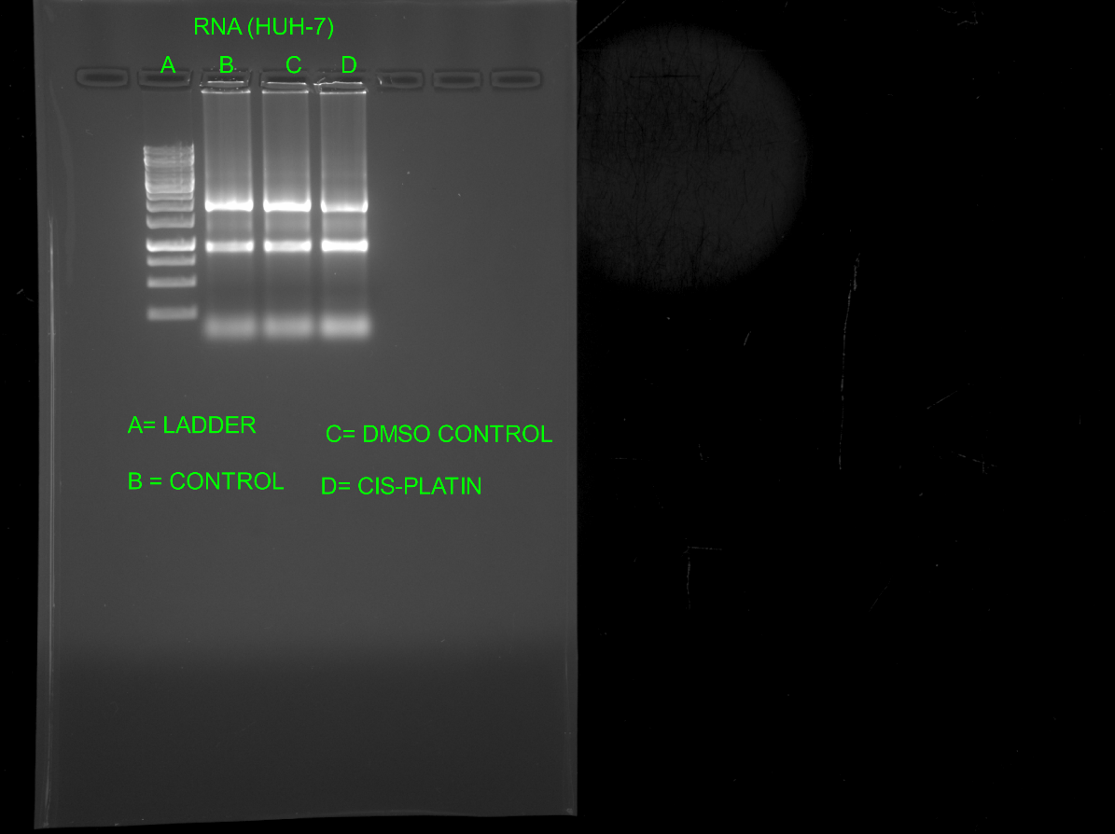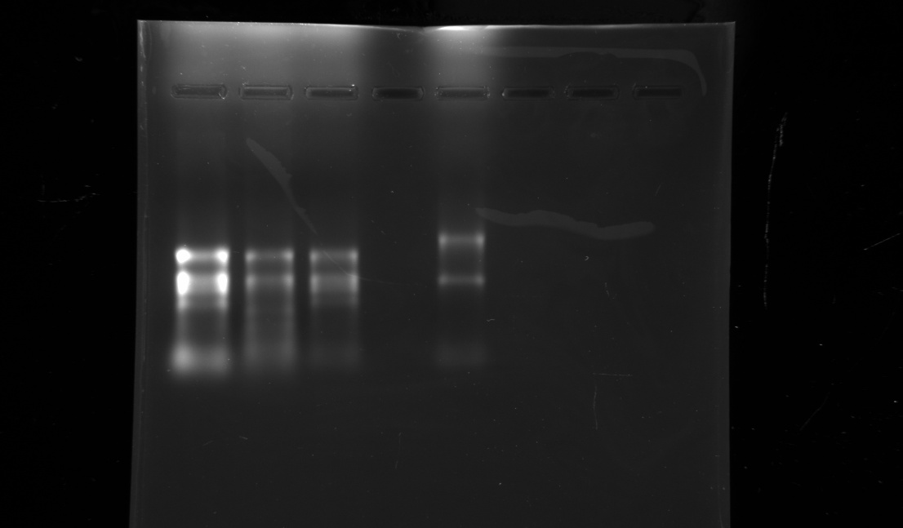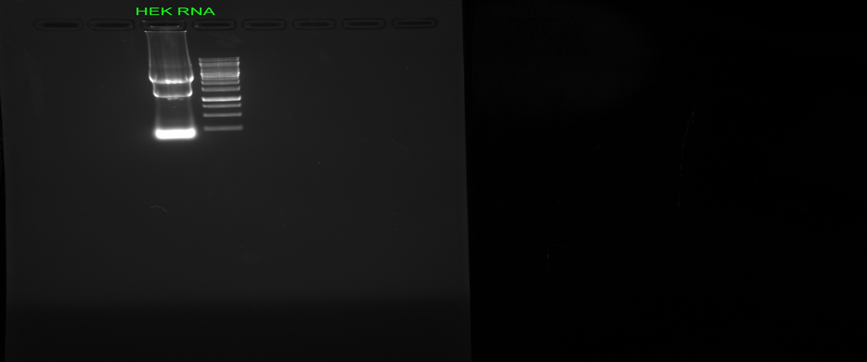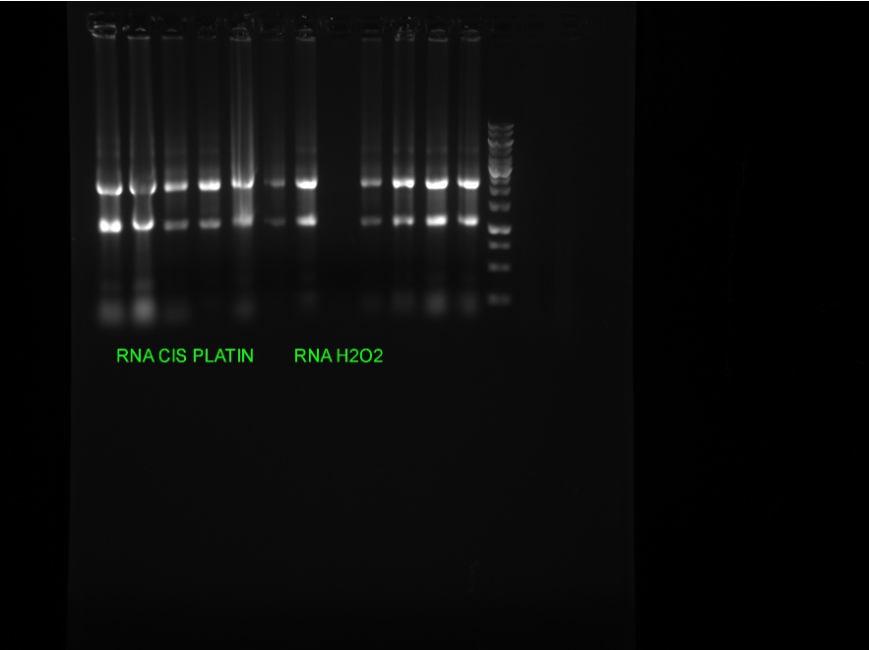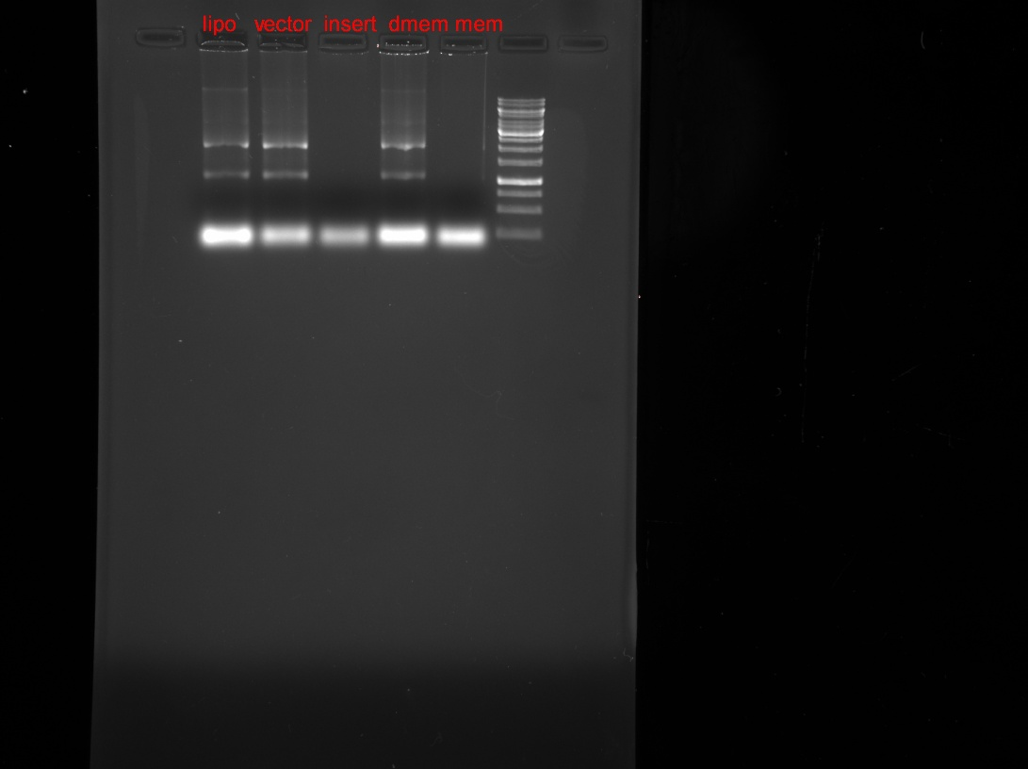

PC3 C DMSO CIS

**Figure 5** Showing RNA band form different cell line.

* **PONs expression in different cell line:-**

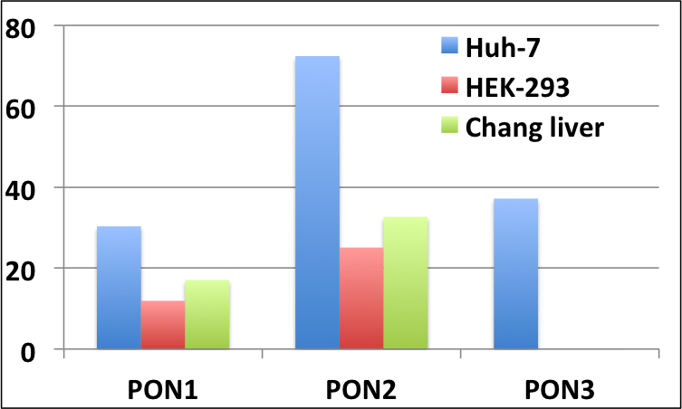

**Figure-6** Showing the expression level of PON1, 2 and 3 proteins in different cell lines demonstrate that PON1 and PON2 are expressed in hepatic carcinoma cell line (Huh-7), Kidney cell line (HEK-293) as well as in Chang liver cell lines, however PON3 is expressed only in Huh-7 cell lines.

* **Decrease level of PON2 in Cis-platin treated cell:-**

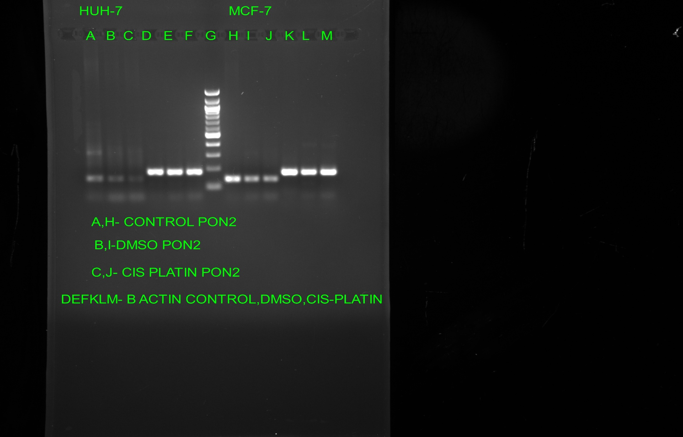

CTRL DMSO CIS.PLATIN

PON2



β-Actin

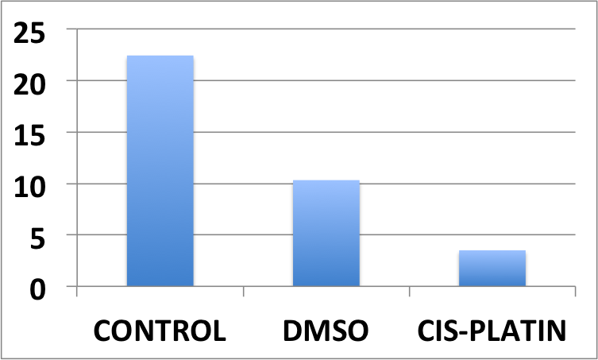

HUH-7



CTRL DMSO CIS.PLATIN

PON2

β-Actin

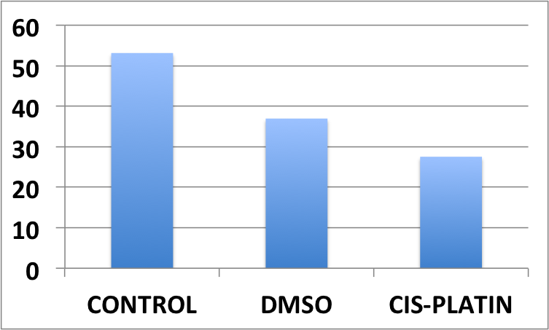

MCF-7

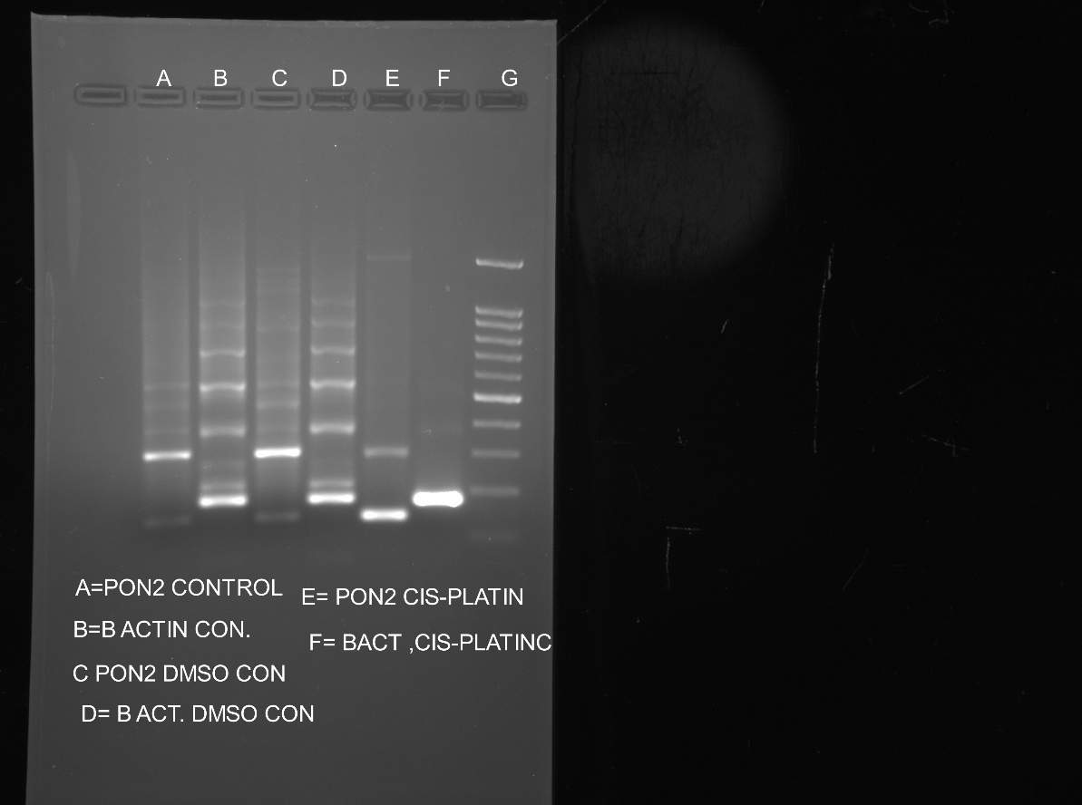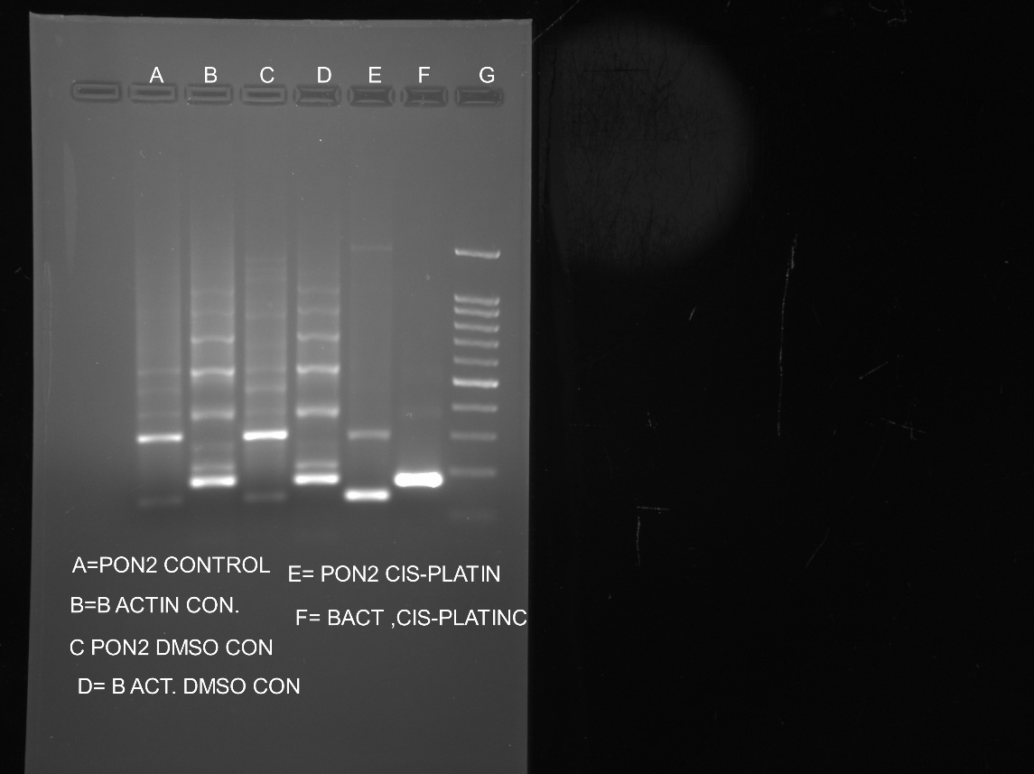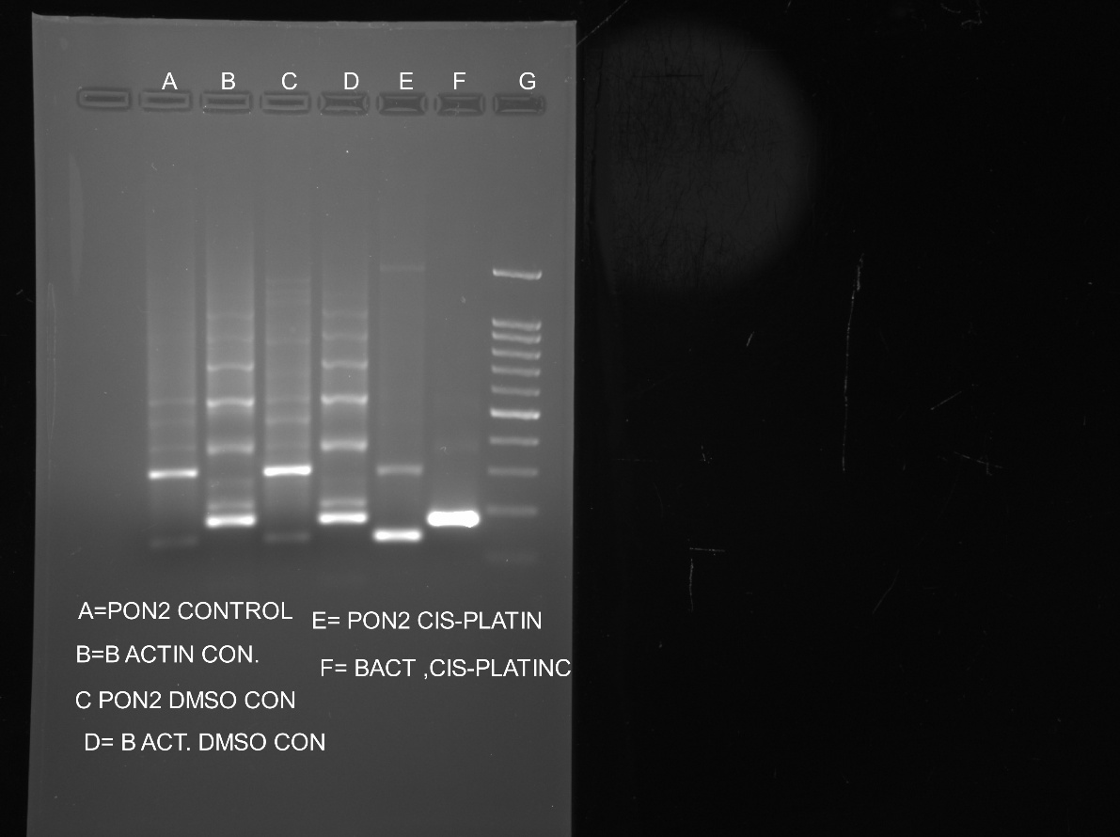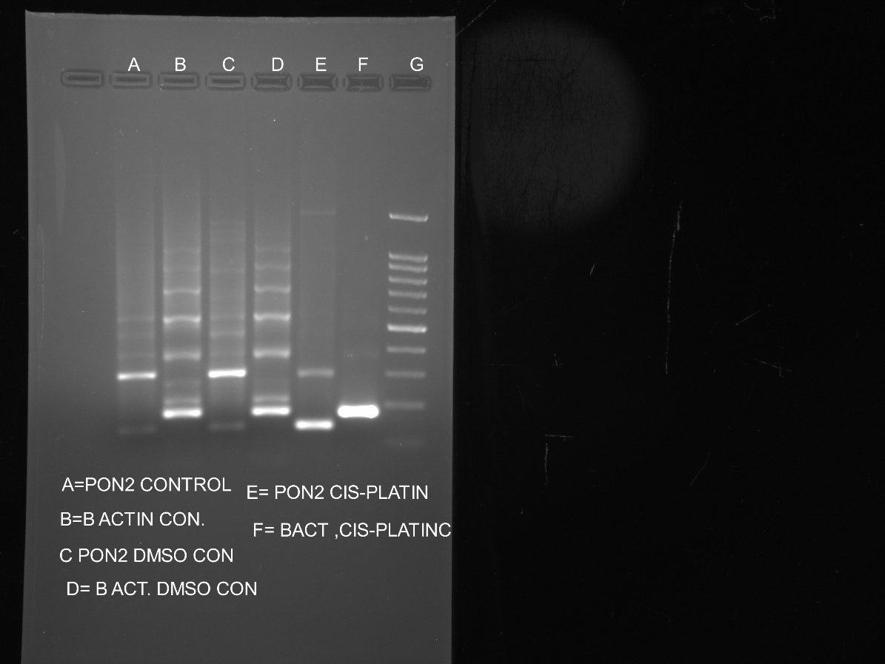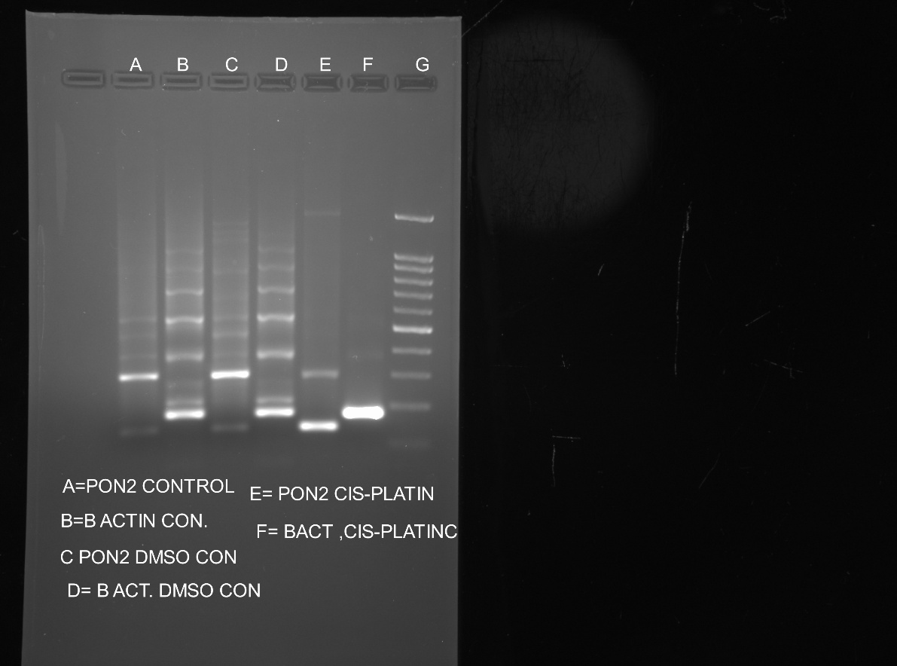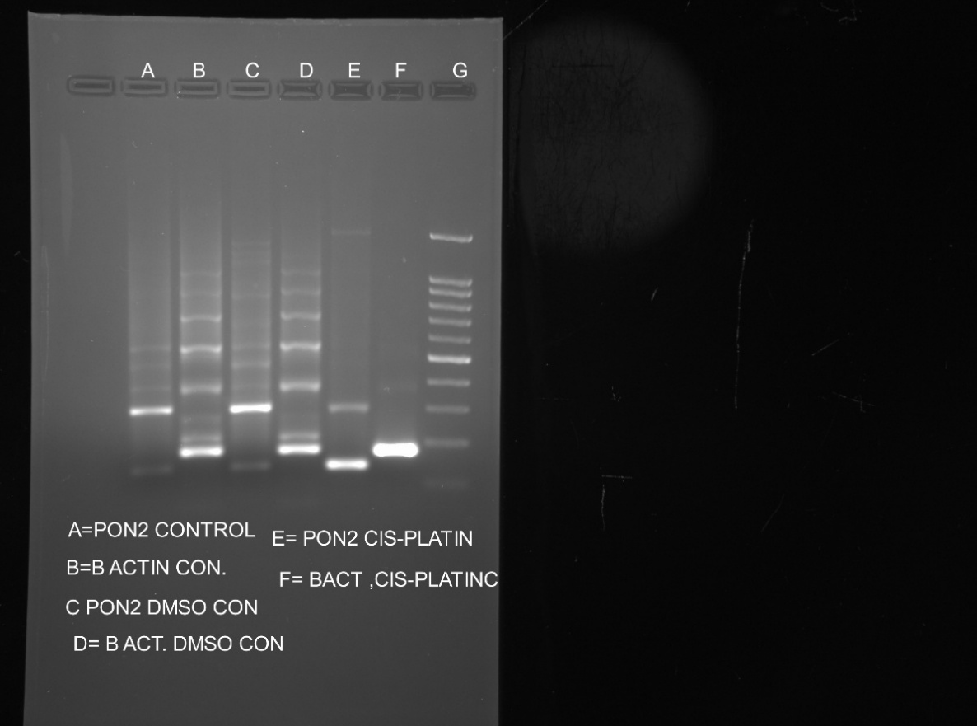

CTRL DMSO CIS-PLATIN CIS-PLATIN

PON2

β-Actin

**Figure-7** Showing the decreased expression of PON2 in different cell line when treated with

50µM of cis-platin.

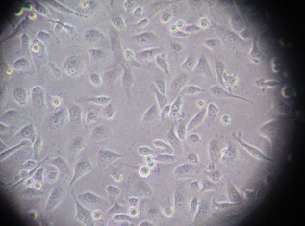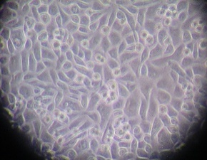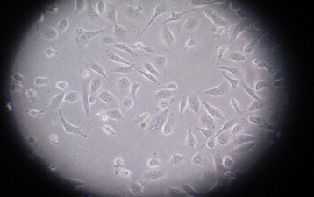

Control DMSO Cis-platin

**Figure-8** Microscopic view of PC-3 cell showing decline cell number in treated cell

* **Decrease in PON2 expression due to oxidative stress:-**

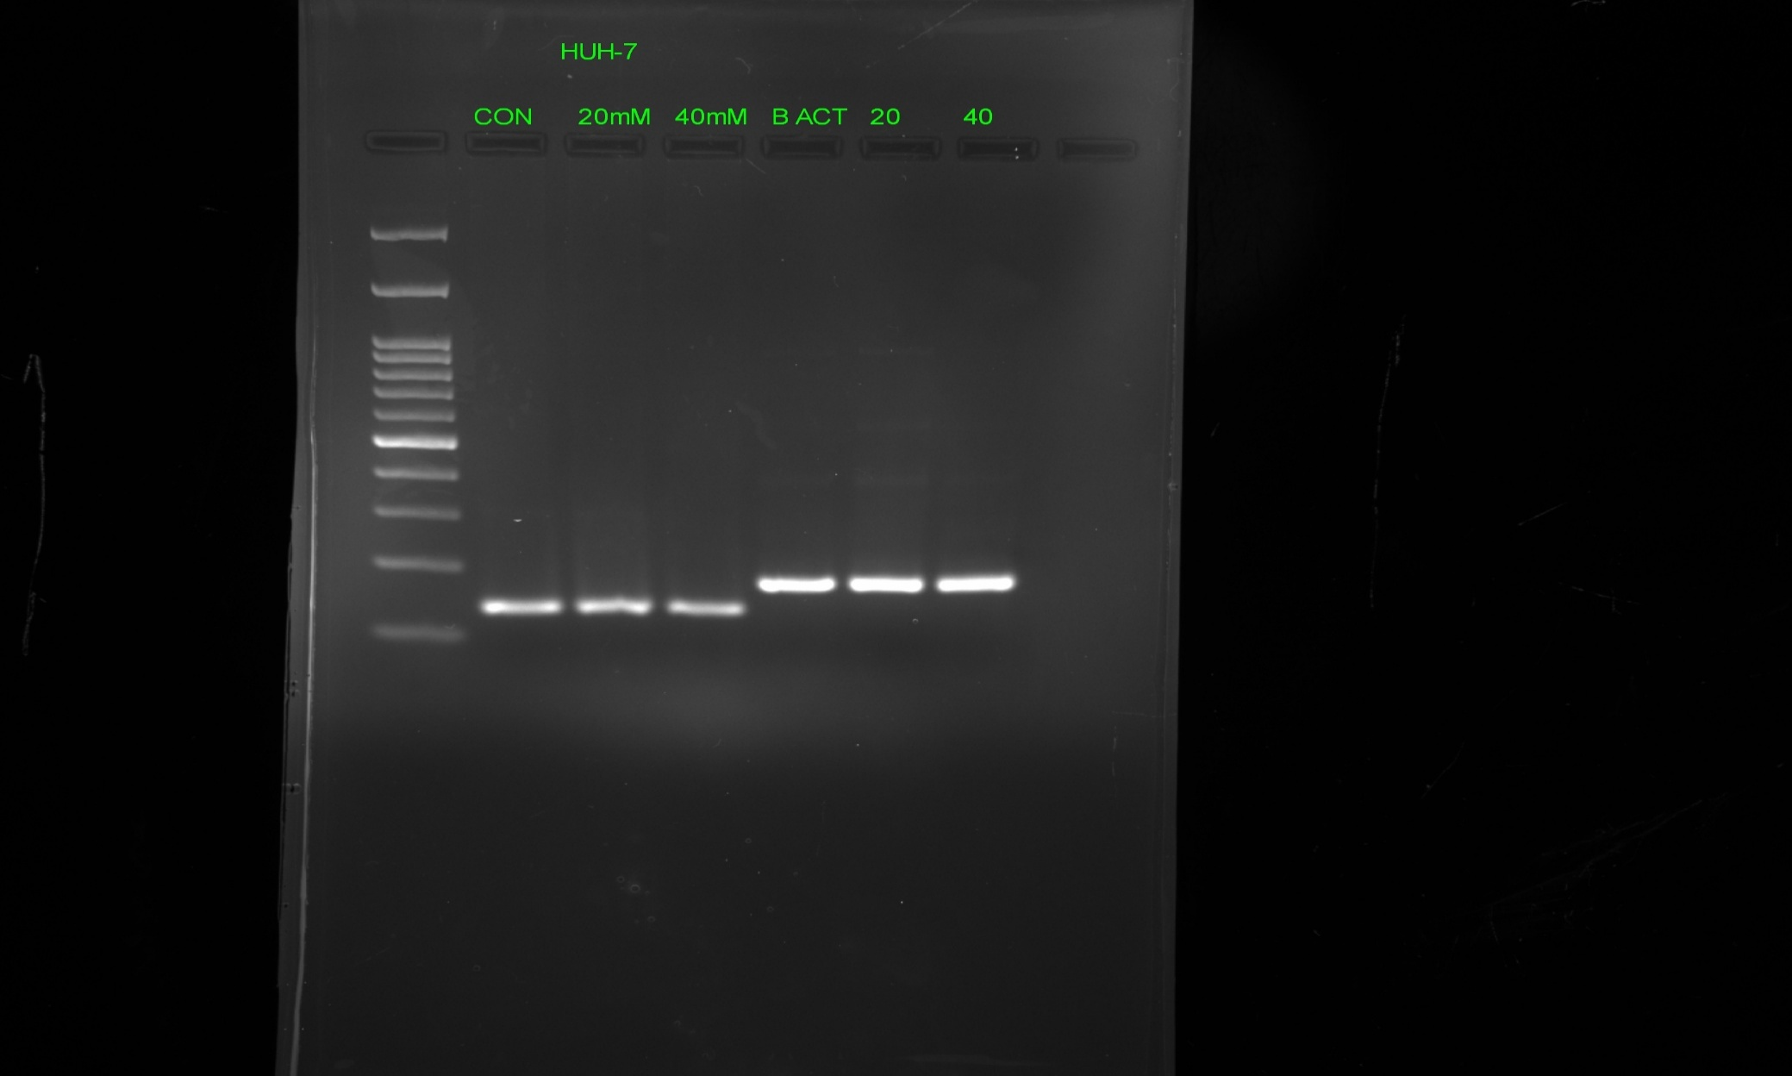

**Ctrl 20µM 40µM**

PON2

β-Actin

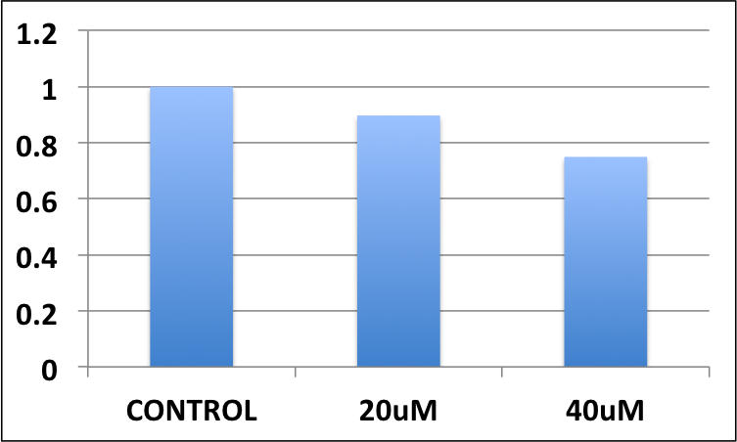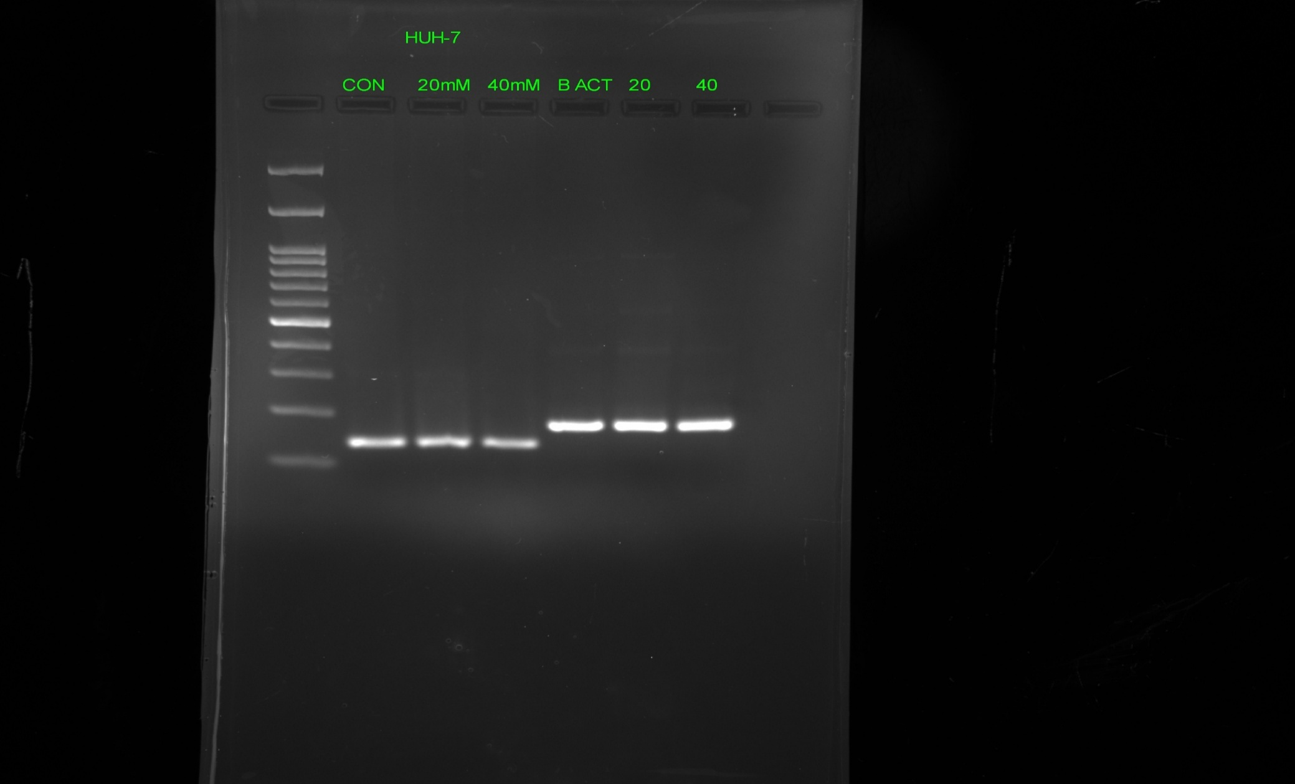

HUH-7

**Figure-9** Showing the decrease in PON2 expression when treated with 20µM & 40µM of

H2O2 .

* **PON3 over expression may decrease the cell proliferation.**

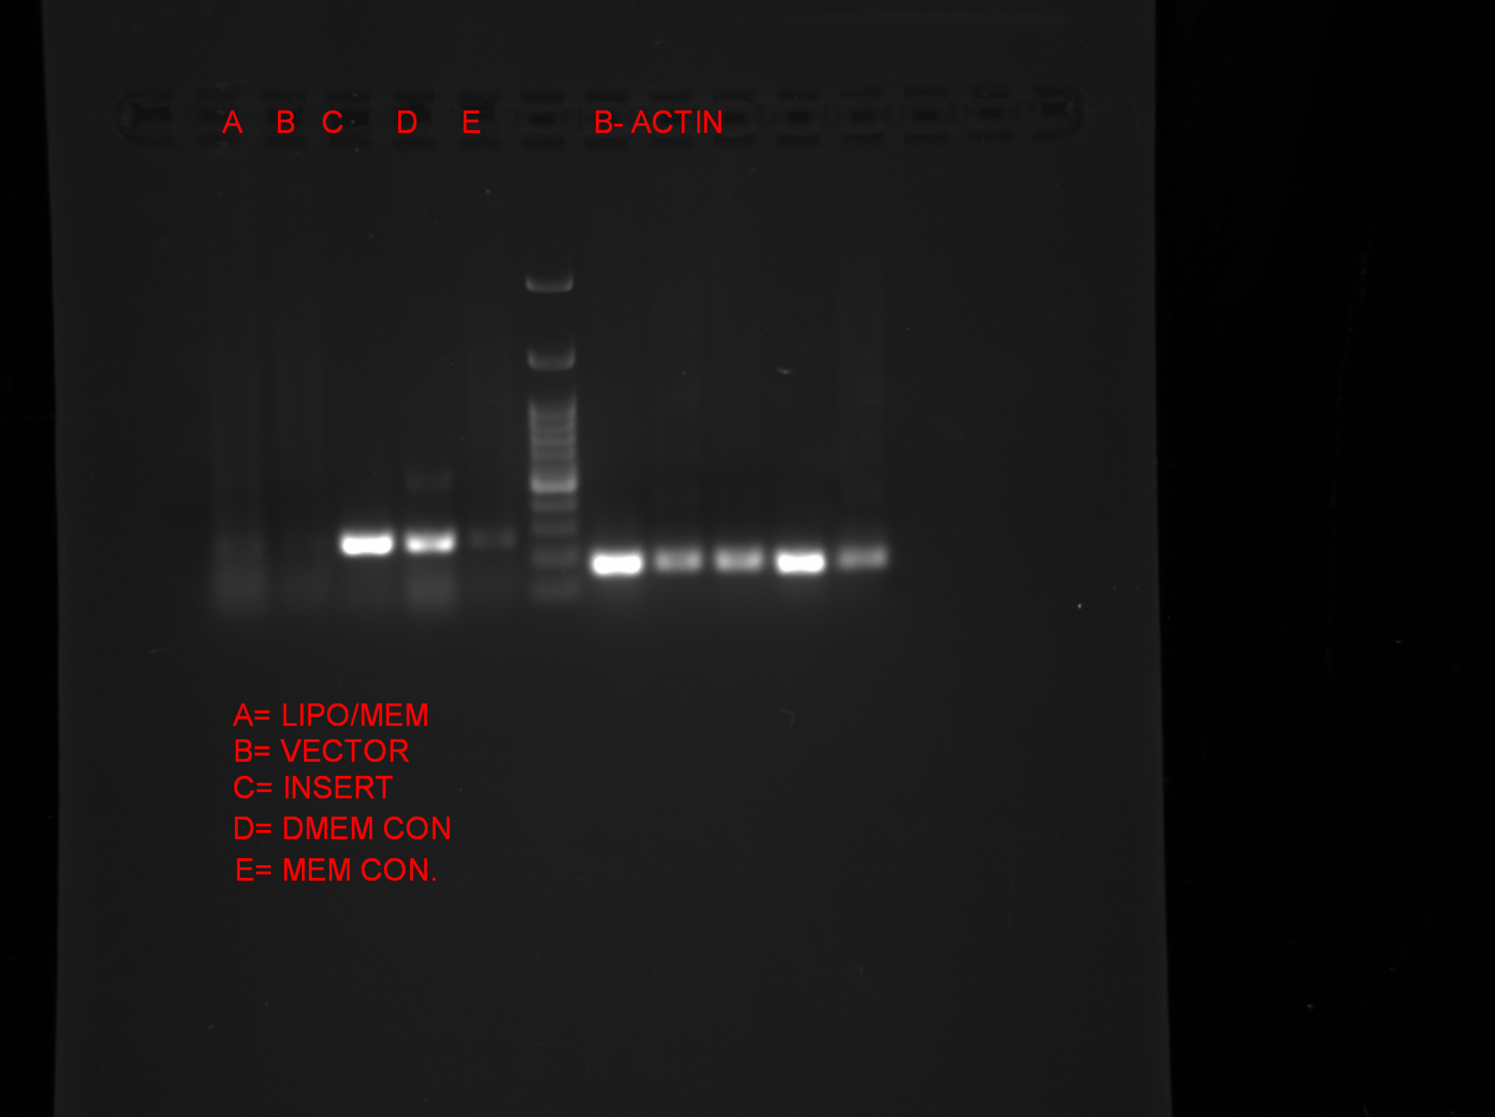

L/M V I DM MEM

PON3

**β**-Actin

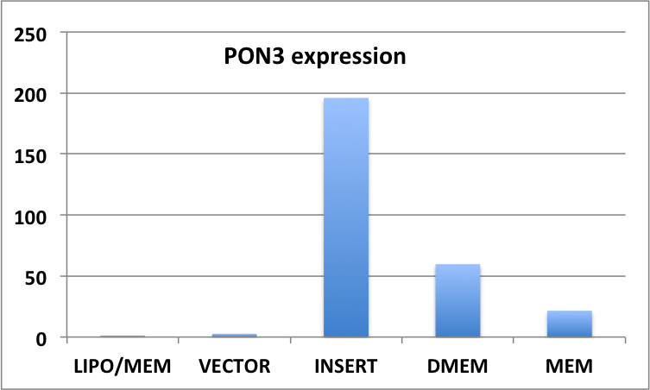

**Figure-10** Cloned PON3 transfected in HUH-7cell and overexpression was seen.

* **Drug (SS209A) testing by MTT assay for cell viability.**

**Figure11** Showing absorbance values that are lower than the control cells indicate a reduction in the rate of Cell proliferation. Conversely a higher absorbance rate indicates an increase in cell proliferation.The different concentration of drug (10, 20, 50,100&200µM) when apply to the cell (mcf-7), that shows the more reduction proliferation in 72hr than 48hr.

* **Decrease PON2 expression when drug (ss209A) treated on MCF-7 cell:-**

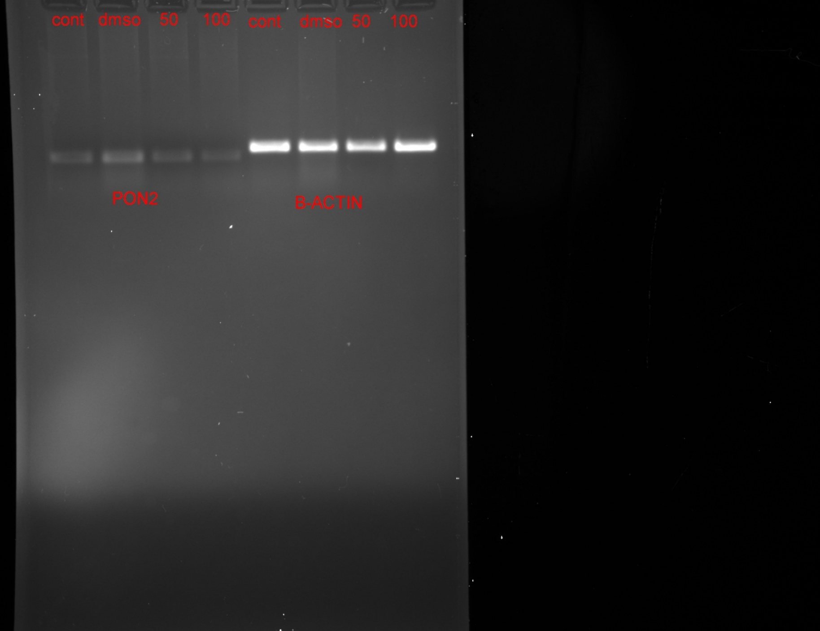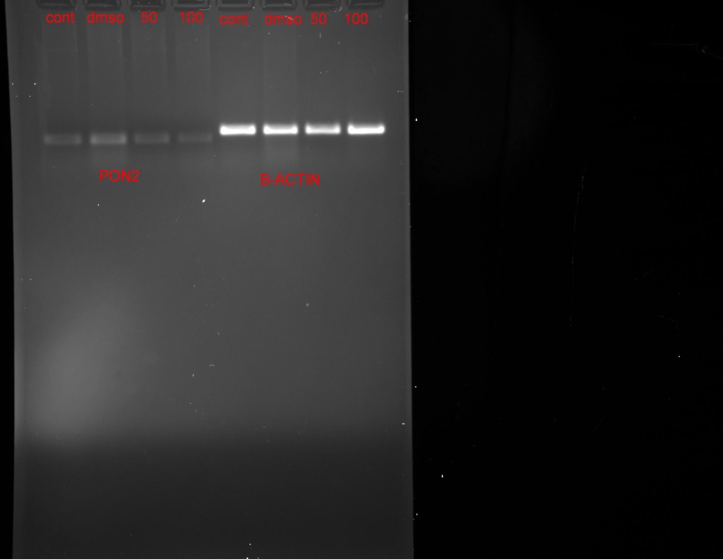

Ctrl DMSO 50μM 100μM

PON2

β-Actin

**Figure-12** Showing the PON2 expression decreases when treated with drug (ss209A) on mcf- 7 cell.

**8) CONCLUSION:-**

Our Investigation on the expression level of PON1, 2 and 3 proteins in different cell lines demonstrate that PON1 and PON2 are expressed in hepatic carcinoma cell line (Huh-7), Kidney cell line (HEK-293) as well as in Chang liver cell lines, however PON3 is expressed only in Huh-7 cell lines. We also observed that the expression level of PON2 in Huh 7 cell lines in response to oxidative stress. Hence, the Huh 7 cells were treated with 20uM and 40uM of H2O2, which showed decrease level of PON2. Similarly, the level of PON2 has gone down due to cis-platin treatment in Huh7, MCF7 and PC-3 cell lines and also by SS209A drug. These findings suggest that the PON2 might help in apoptotic escape and stabilizes the cancerous cells. For further confirmation, we design the experiments to overexpress PON3 in Huh7 cell line and see the effect on cell proliferation and apoptosis. PON2 and PON3 were cloned in pcDNA mammalian expression vector and transfected to the cell lines. We have successfully transfected the PON3 gene and have shown the overexpression also in Huh7 cell lines.

Further investigation is required to completely elucidate the mechanism of action of PON2 through cell and molecular biology techniques. These studies will hence enlighten us in better understanding the role of the enzyme in cell proliferation and apoptosis.

**References**

Aharoni, A., Gaidukov, L., Yagur, S., Toker, L., Silman, I., and Tawfik, D.S. (2004). Directed evolution of mammalian paraoxonases PON1 and PON3 for bacterial expression and catalytic specialization. Proc. Natl. Acad. Sci. U. S. A. *101*, 482–487.

Altenhöfer, S., Witte, I., Teiber, J.F., Wilgenbus, P., Pautz, A., Li, H., Daiber, A., Witan, H., Clement, A.M., Förstermann, U., et al. (2010). One enzyme, two functions: PON2 prevents mitochondrial superoxide formation and apoptosis independent from its lactonase activity. J. Biol. Chem. *285*, 24398–24403.

Aviram, M., Rosenblat, M., Bisgaier, C.L., Newton, R.S., Primo-Parmo, S.L., and La Du, B.N. (1998). Paraoxonase inhibits high-density lipoprotein oxidation and preserves its functions. A possible peroxidative role for paraoxonase. J. Clin. Invest. *101*, 1581–1590.

Besler, C., Lüscher, T.F., and Landmesser, U. (2012). Molecular mechanisms of vascular effects of High-density lipoprotein: alterations in cardiovascular disease. EMBO Mol. Med. *4*, 251–268.

Chen, F., Gao, Y., Chen, X., Yu, Z., and Li, X. (2013). Quorum Quenching Enzymes and Their Application in Degrading Signal Molecules to Block Quorum Sensing-Dependent Infection. Int. J. Mol. Sci. *14*, 17477–17500.

Costa, L.G., de Laat, R., Dao, K., Pellacani, C., Cole, T.B., and Furlong, C.E. (2014). Paraoxonase-2 (PON2) in brain and its potential role in neuroprotection. NeuroToxicology *43*, 3–9.

Eren, E., Yilmaz, N., and Aydin, O. (2012). High Density Lipoprotein and it’s Dysfunction. Open Biochem. J. *6*, 78–93.

Forte, T.M., Subbanagounder, G., Berliner, J.A., Blanche, P.J., Clermont, A.O., Jia, Z., Oda, M.N., Krauss, R.M., and Bielicki, J.K. (2002). Altered activities of anti-atherogenic enzymes LCAT, paraoxonase, and platelet-activating factor acetylhydrolase in atherosclerosis-susceptible mice. J. Lipid Res. *43*, 477–485.

Giordano, G., Cole, T.B., Furlong, C.E., and Costa, L.G. (2011). Paraoxonase 2 (PON2) in the mouse central nervous system: a neuroprotective role? Toxicol. Appl. Pharmacol. *256*, 369–378.

Harel, M., Aharoni, A., Gaidukov, L., Brumshtein, B., Khersonsky, O., Meged, R., Dvir, H., Ravelli, R.B.G., McCarthy, A., Toker, L., et al. (2004). Structure and evolution of the serum paraoxonase family of detoxifying and anti-atherosclerotic enzymes. Nat. Struct. Mol. Biol. *11*, 412–419.

Krishnamurthy, P., and Wadhwani, A. (2012). Antioxidant Enzymes and Human Health. In Antioxidant Enzyme, M.A. El-Missiry, ed. (InTech), p.

Kuo, C.L., and La Du, B.N. (1998). Calcium binding by human and rabbit serum paraoxonases. Structural stability and enzymatic activity. Drug Metab. Dispos. Biol. Fate Chem. *26*, 653–660.

Levy, E., Trudel, K., Bendayan, M., Seidman, E., Delvin, E., Elchebly, M., Lavoie, J.-C., Precourt, L.-P., Amre, D., and Sinnett, D. (2007). Biological role, protein expression, subcellular localization, and oxidative stress response of paraoxonase 2 in the intestine of humans and rats. Am. J. Physiol. Gastrointest. Liver Physiol. *293*, G1252-1261.

Liu, Z., Lv, Y., Zhao, N., Guan, G., and Wang, J. (2015). Protein kinase R-like ER kinase and its role in endoplasmic reticulum stress-decided cell fate. Cell Death Dis. *6*, e1822.

Mackness, M., and Mackness, B. (2015). Human paraoxonase-1 (PON1): Gene structure and expression, promiscuous activities and multiple physiological roles. Gene *567*, 12–21.

Ng, C.J., Wadleigh, D.J., Gangopadhyay, A., Hama, S., Grijalva, V.R., Navab, M., Fogelman, A.M., and Reddy, S.T. (2001). Paraoxonase-2 is a ubiquitously expressed protein with antioxidant properties and is capable of preventing cell-mediated oxidative modification of low density lipoprotein. J. Biol. Chem. *276*, 44444–44449.

Nishitoh, H. (2012). CHOP is a multifunctional transcription factor in the ER stress response. J. Biochem. (Tokyo) *151*, 217–219.

Ponce-Ruiz, N., Rojas-García, A.E., Barrón-Vivanco, B.S., Elizondo, G., Bernal-Hernández, Y.Y., Mejía-García, A., and Medina-Díaz, I.M. (2015). Transcriptional regulation of human paraoxonase 1 by PXR and GR in human hepatoma cells. Toxicol. Vitro Int. J. Publ. Assoc. BIBRA *30*, 348–354.

Rosenblat, M., Draganov, D., Watson, C.E., Bisgaier, C.L., La Du, B.N., and Aviram, M. (2003). Mouse macrophage paraoxonase 2 activity is increased whereas cellular paraoxonase 3 activity is decreased under oxidative stress. Arterioscler. Thromb. Vasc. Biol. *23*, 468–474.

Shih, D.M., Gu, L., Hama, S., Xia, Y.R., Navab, M., Fogelman, A.M., and Lusis, A.J. (1996). Genetic-dietary regulation of serum paraoxonase expression and its role in atherogenesis in a mouse model. J. Clin. Invest. *97*, 1630–1639.

Shiner, M., Fuhrman, B., and Aviram, M. (2004). Paraoxonase 2 (PON2) expression is upregulated via a reduced-nicotinamide-adenine-dinucleotide-phosphate (NADPH)-oxidase-dependent mechanism during monocytes differentiation into macrophages. Free Radic. Biol. Med. *37*, 2052–2063.

Shiner, M., Fuhrman, B., and Aviram, M. (2007). Macrophage paraoxonase 2 (PON2) expression is up-regulated by pomegranate juice phenolic anti-oxidants via PPAR gamma and AP-1 pathway activation. Atherosclerosis *195*, 313–321.

Siddik, Z.H. (2003). Cisplatin: mode of cytotoxic action and molecular basis of resistance. Oncogene *22*, 7265–7279.

Teiber, J.F., Horke, S., Haines, D.C., Chowdhary, P.K., Xiao, J., Kramer, G.L., Haley, R.W., and Draganov, D.I. (2008). Dominant role of paraoxonases in inactivation of the Pseudomonas aeruginosa quorum-sensing signal N-(3-oxododecanoyl)-L-homoserine lactone. Infect. Immun. *76*, 2512–2519.

Witte, I., Altenhöfer, S., Wilgenbus, P., Amort, J., Clement, A.M., Pautz, A., Li, H., Förstermann, U., and Horke, S. (2011). Beyond reduction of atherosclerosis: PON2 provides apoptosis resistance and stabilizes tumor cells. Cell Death Dis. *2*, e112.

Yeung, D.T., Josse, D., Nicholson, J.D., Khanal, A., McAndrew, C.W., Bahnson, B.J., Lenz, D.E., and Cerasoli, D.M. (2004). Structure/function analyses of human serum paraoxonase (HuPON1) mutants designed from a DFPase-like homology model. Biochim. Biophys. Acta *1702*, 67–77.