## 

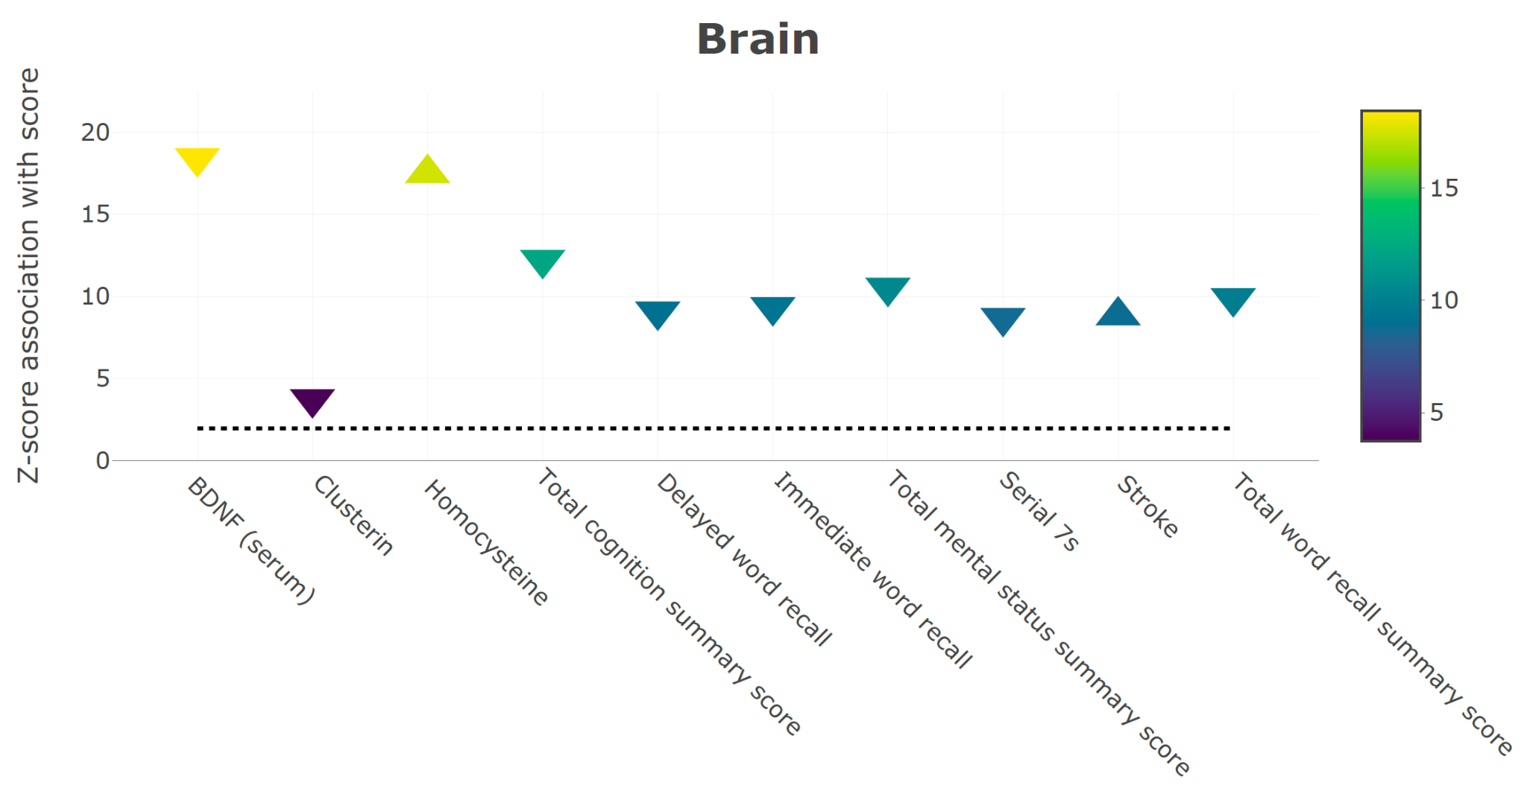

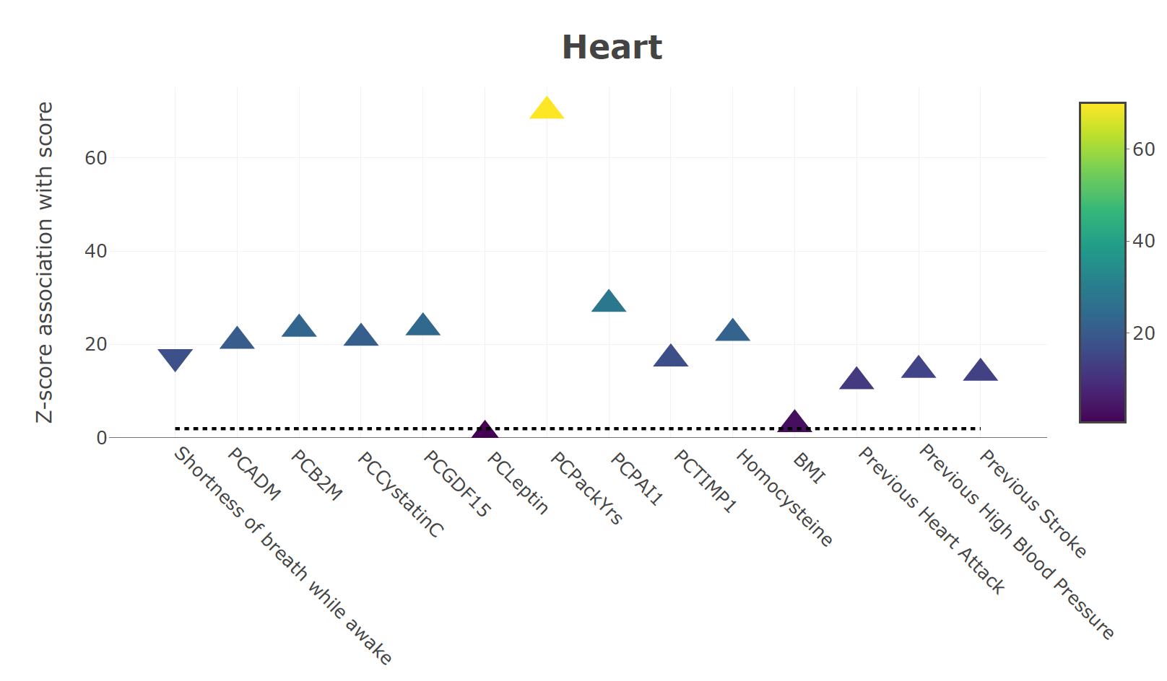

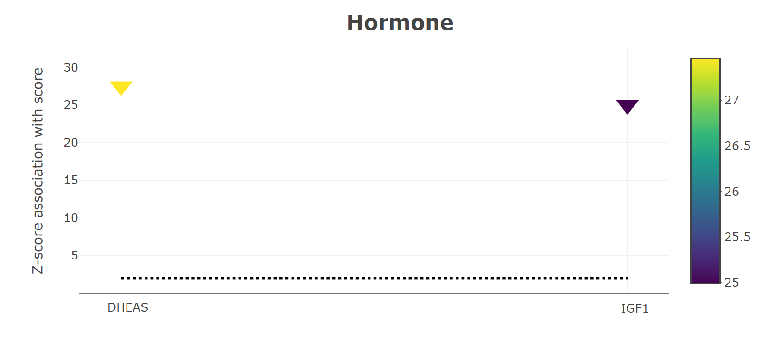

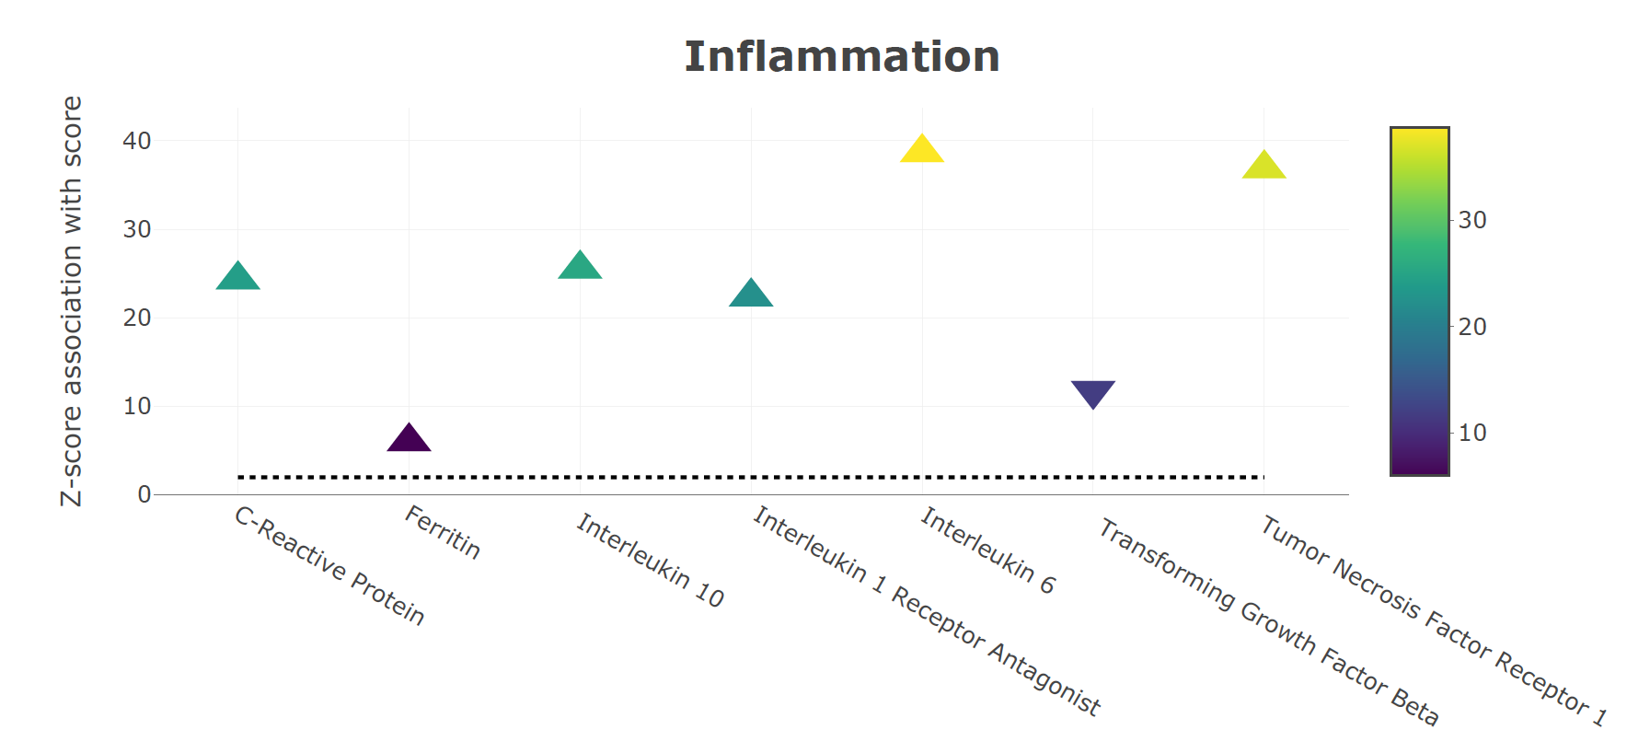

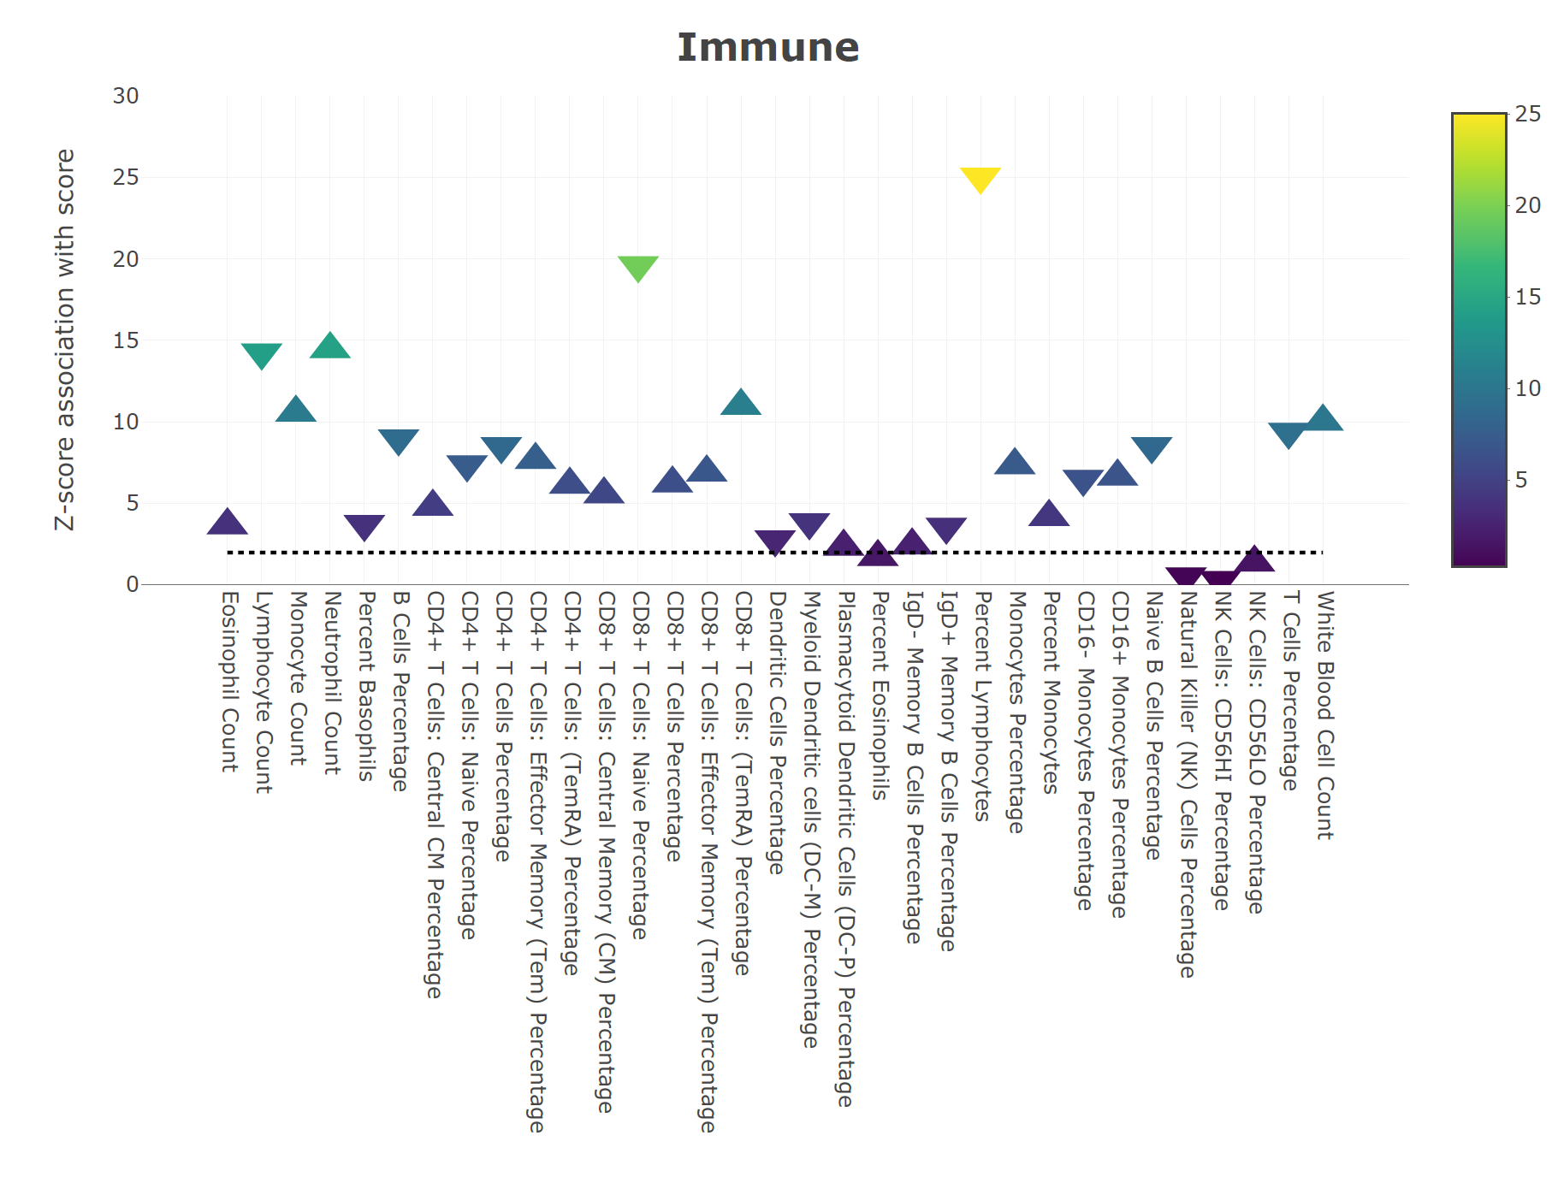

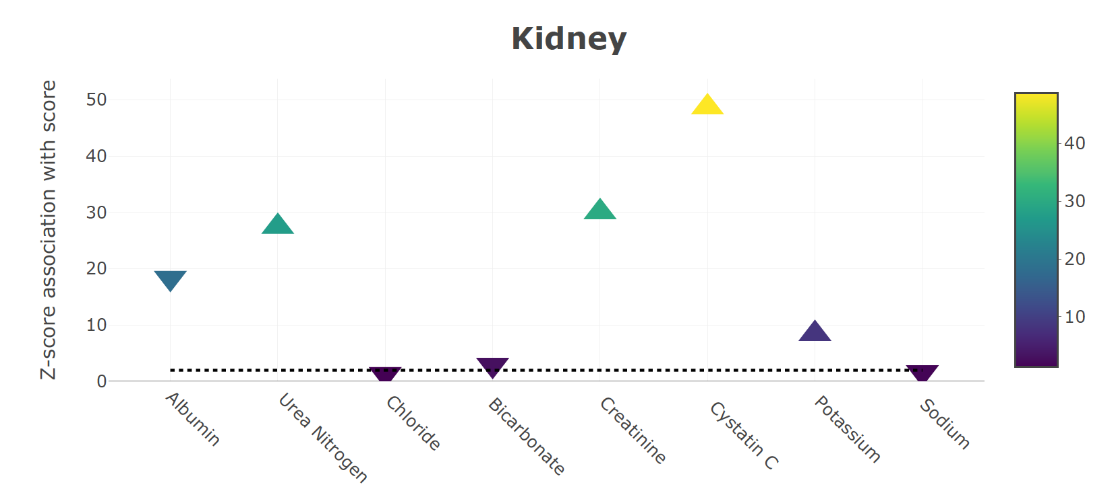

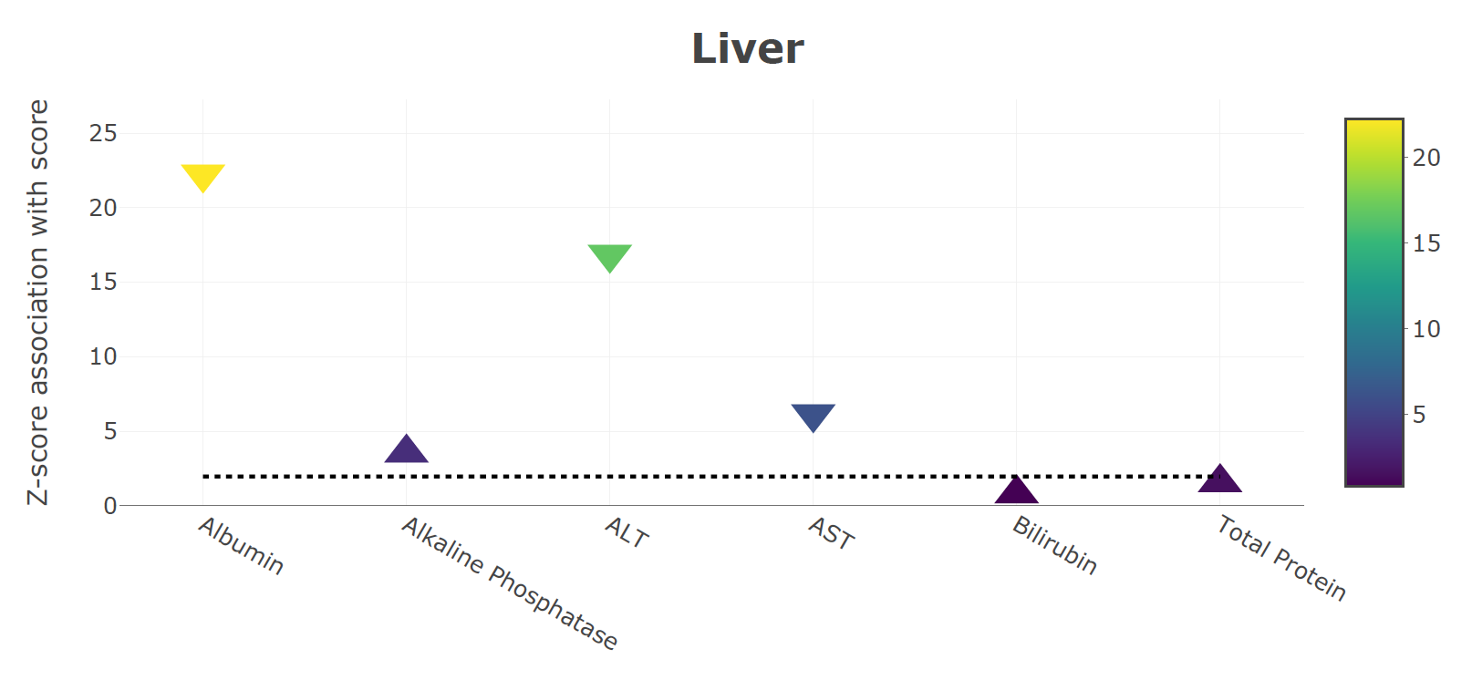

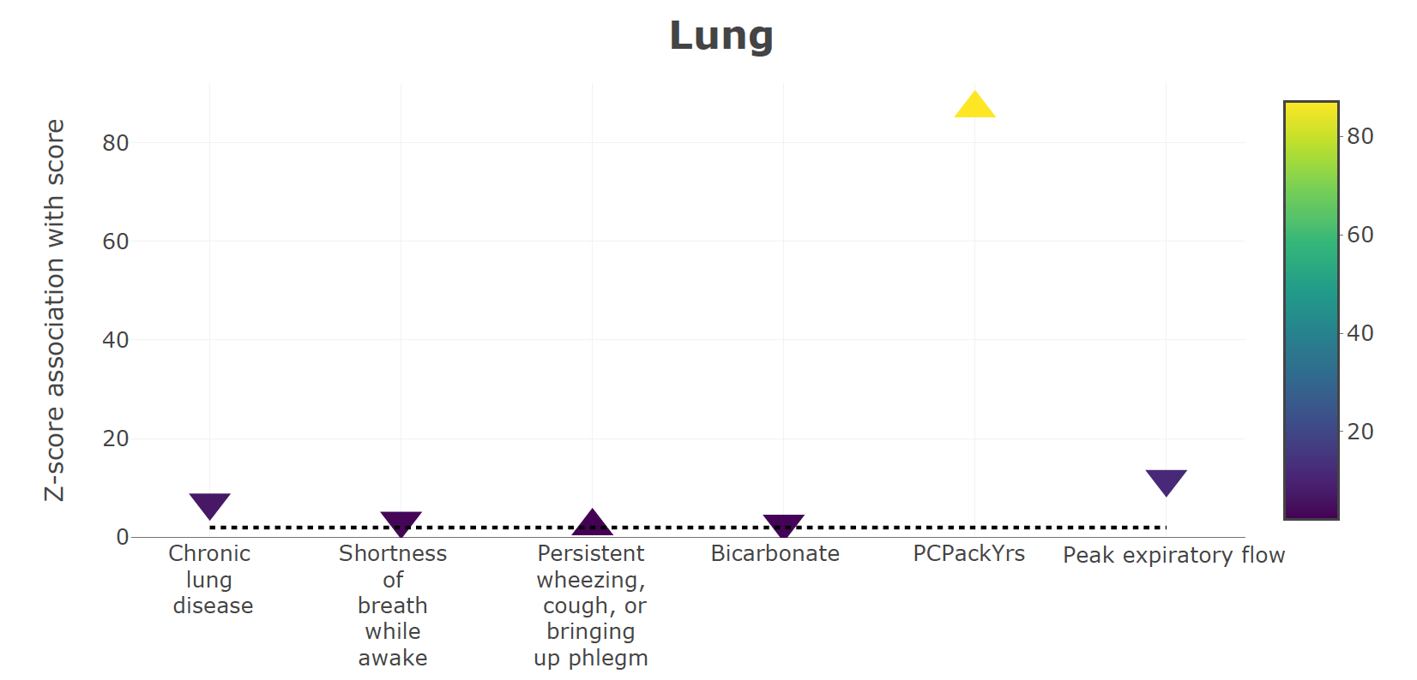

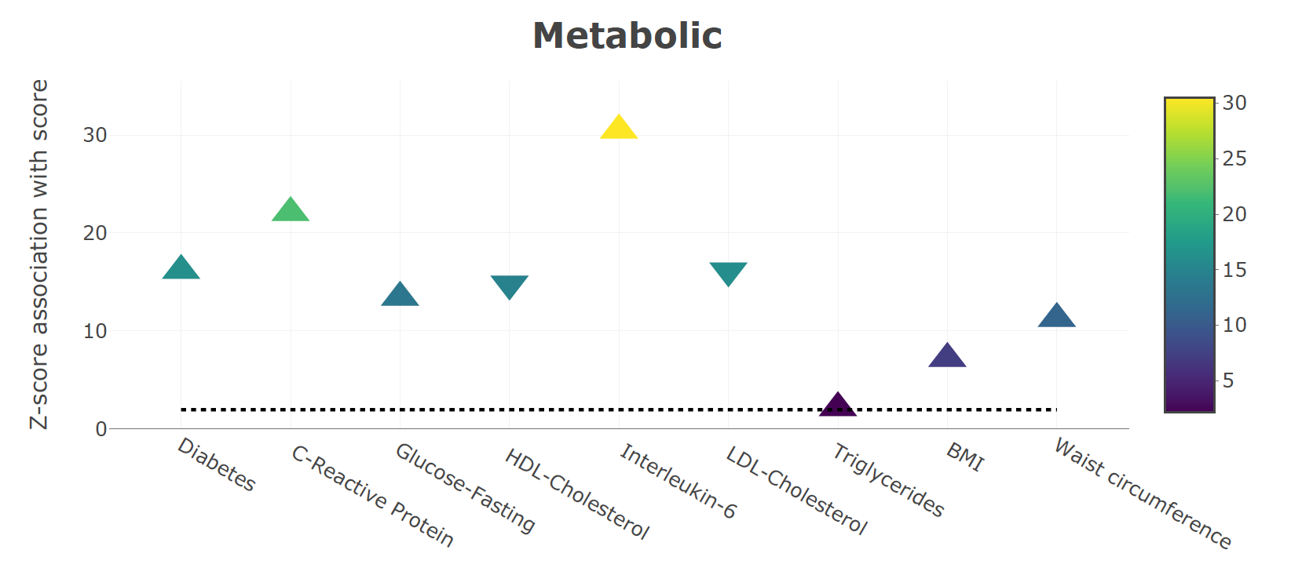

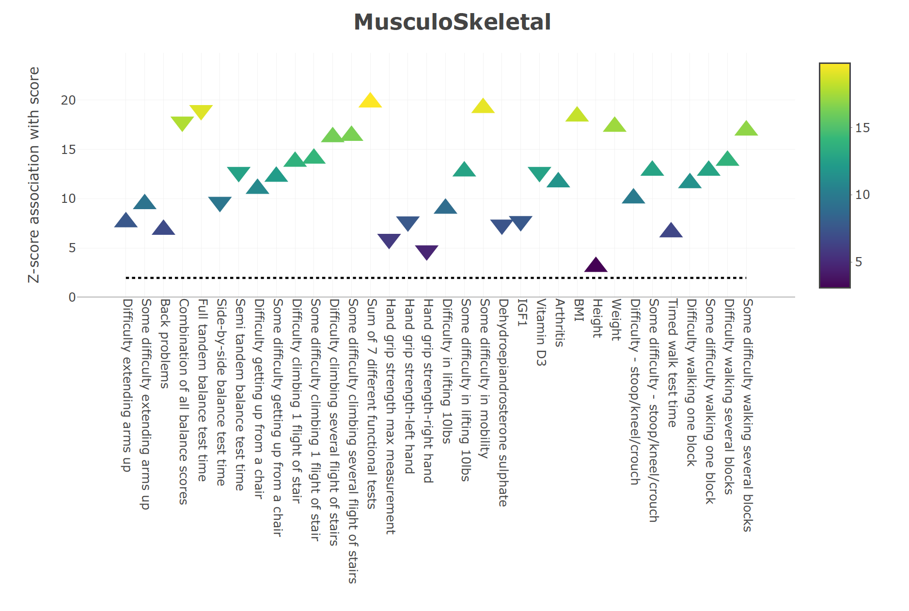

*Supplementary Figure 1 : Associations of Biomarkers with System specific scores in HRS. Each system score was calculated in 3593 samples in HRS. For each of the system scores the respective biomarkers pertaining to each system were associated using a linear model to observe the z-score of association which were then plotted on the above graphs.*

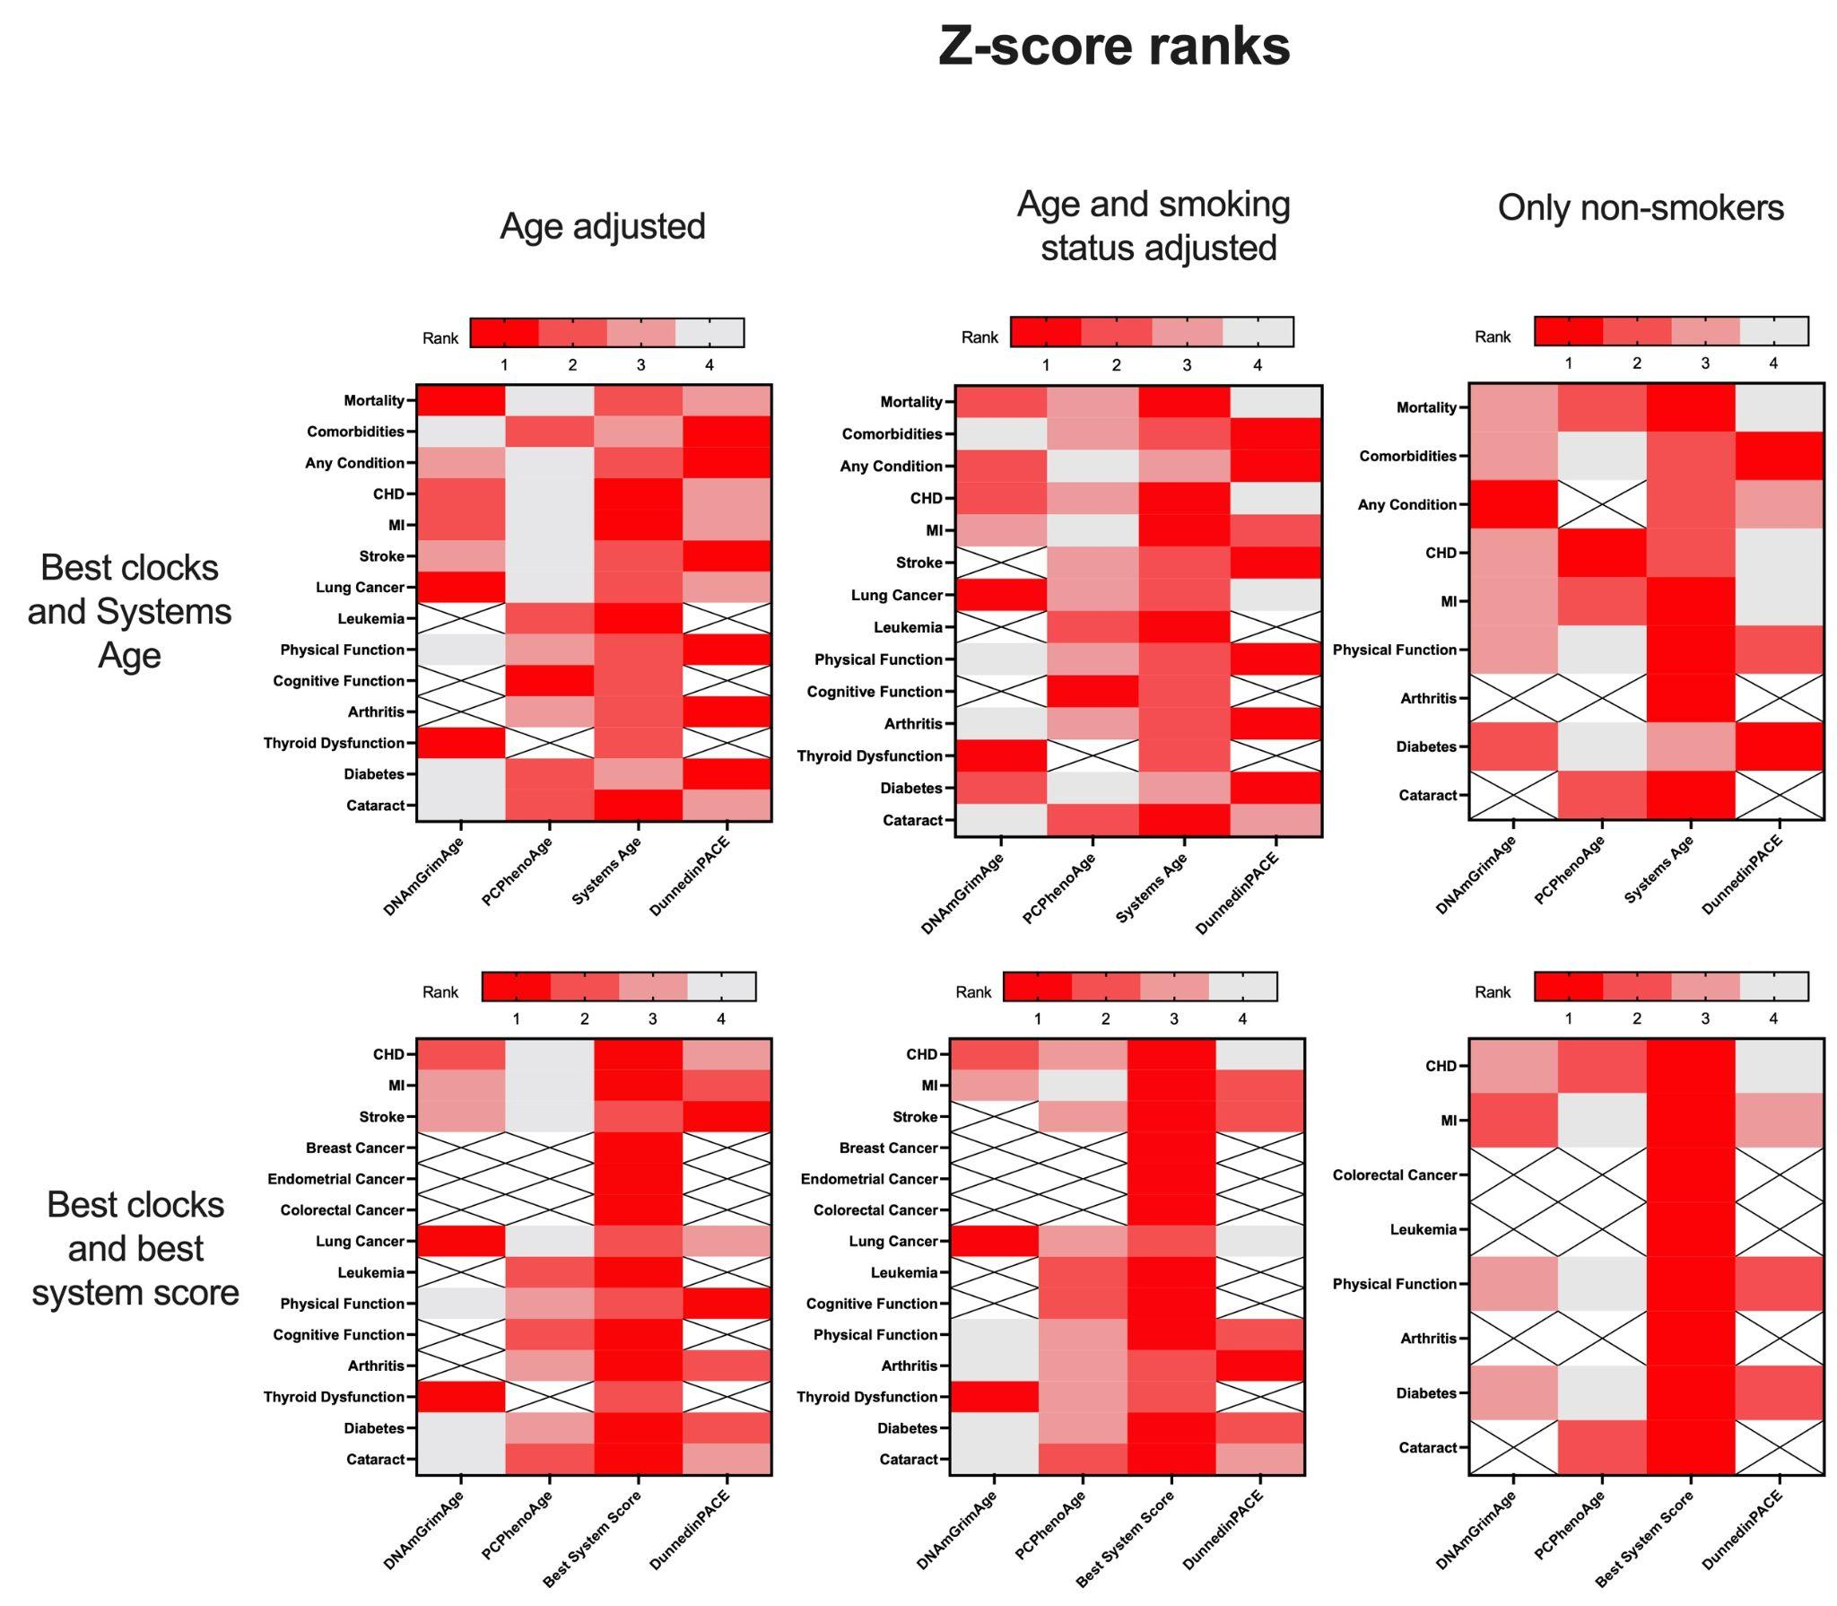

*Supplementary figure 2: Ranks of clocks based on z-scores with age adjusted, age and smoking status adjusted and age adjusted only for non-smokers. Z-scores were calculated using race stratified meta analysis on 3 WHI cohorts: EMPC, AS311 and BAA23. Ranks are shown for only those variables which had at least 1 significant z-score. Plots generated using Prism 9.*

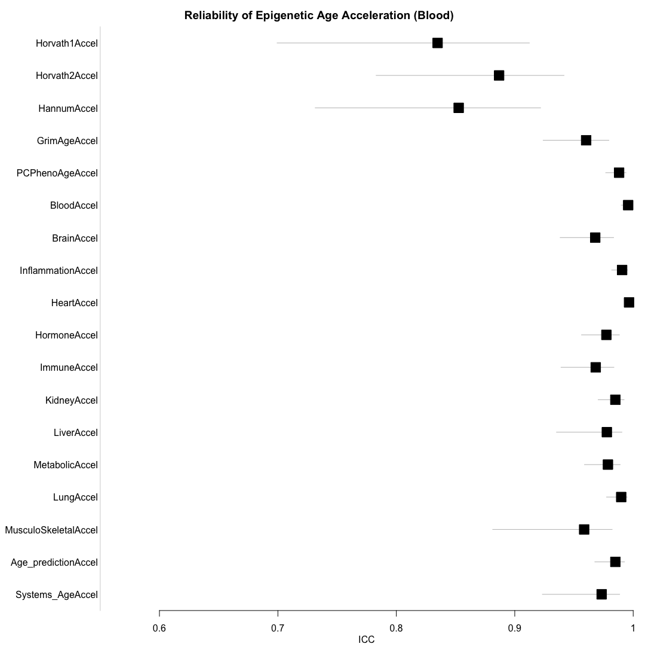

*Supplementary figure 3: Reliability of different age accelerated system scores and Systems Age as compared to other clocks. Reliability was calculated as described before (Higgins-Chen et al. 2022). Briefly, reliability was calculated in GSE55763 which consisted of 36 whole-blood samples measured in duplicate (age range 37.3 to 74.6). We used the icc function in the irr R package version 0.84.1, using a single-rater, absolute-agreement, two-way random-effects model.*